UNITED STATES
SECURITIES AND EXCHANGE COMMISSION
Washington, D.C. 20549

SCHEDULE 14A

Proxy Statement Pursuant to Section 14(a) of
the Securities Exchange Act of 1934 (Amendment No. &numsp;&numsp;)

Filed by the Registrant ☒

Filed by a Party other than the Registrant ☐

Check the appropriate box:

☐ | Preliminary Proxy Statement
☐ | Confidential, for Use of the Commission Only (as permitted by Rule 14a-6(e)(2))
☐ | Definitive Proxy Statement
☒ | Definitive Additional Materials
☐ | Soliciting Material under §240.14a-12

Virtu Financial, Inc.

(Name of Registrant as Specified In Its Charter)

(Name of Person(s) Filing Proxy Statement, if other than the Registrant)

Payment of Filing Fee (Check the appropriate box):

☒ | No fee required.

☐ | Fee paid previously with preliminary materials:

☐ | Fee computed on table in exhibit required by Item 25(b) per Exchange Act Rules 14a6(i)(1) and 0-11.

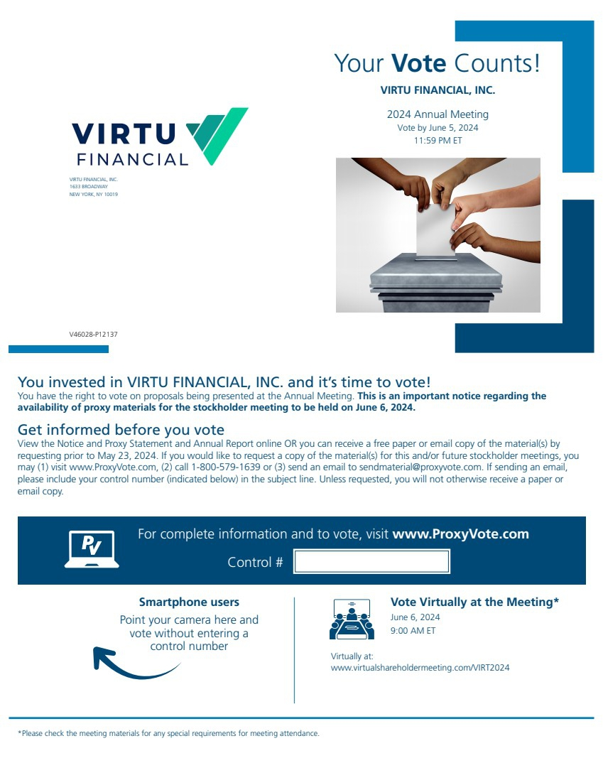 | Your Vote Counts! *Please check the meeting materials for any special requirements for meeting attendance. Smartphone users Point your camera here and vote without entering a control number For complete information and to vote, visit www.ProxyVote.com Control # V46028-P12137 VIRTU FINANCIAL, INC. 1633 BROADWAY NEW YORK, NY 10019 VIRTU FINANCIAL, INC. 2024 Annual Meeting Vote by June 5, 2024 11:59 PM ET You invested in VIRTU FINANCIAL, INC. and it’s time to vote! You have the right to vote on proposals being presented at the Annual Meeting. This is an important notice regarding the availability of proxy materials for the stockholder meeting to be held on June 6, 2024. Vote Virtually at the Meeting* June 6, 2024 9:00 AM ET Virtually at: www.virtualshareholdermeeting.com/VIRT2024 Get informed before you vote View the Notice and Proxy Statement and Annual Report online OR you can receive a free paper or email copy of the material(s) by requesting prior to May 23, 2024. If you would like to request a copy of the material(s) for this and/or future stockholder meetings, you may (1) visit www.ProxyVote.com, (2) call 1-800-579-1639 or (3) send an email to sendmaterial@proxyvote.com. If sending an email, please include your control number (indicated below) in the subject line. Unless requested, you will not otherwise receive a paper or email copy.
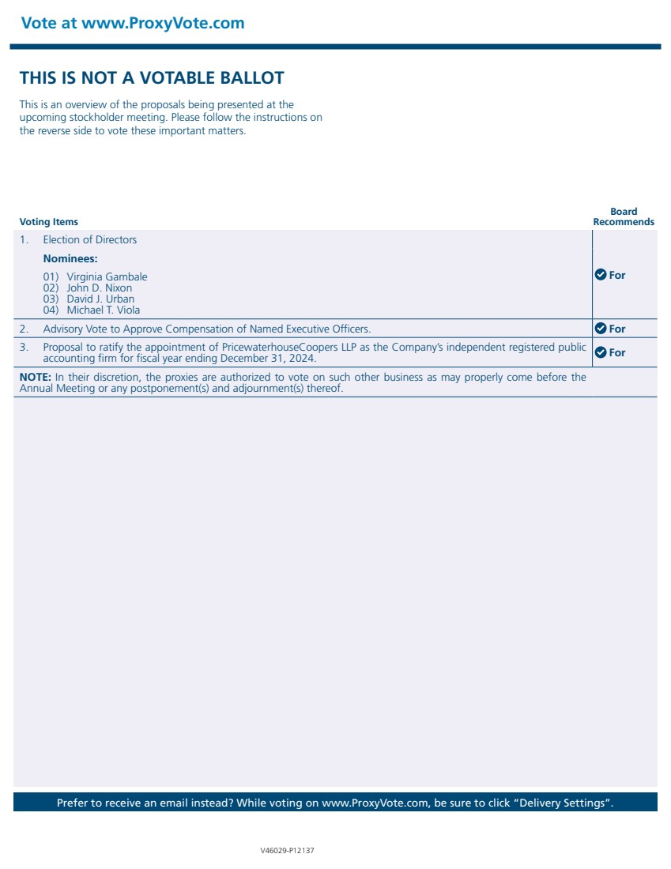 | Vote at www.ProxyVote.com Prefer to receive an email instead? While voting on www.ProxyVote.com, be sure to click “Delivery Settings”. Voting Items Board Recommends V46029-P12137 THIS IS NOT A VOTABLE BALLOT This is an overview of the proposals being presented at the upcoming stockholder meeting. Please follow the instructions on the reverse side to vote these important matters. 1. Election of Directors For Nominees: 01) Virginia Gambale 02) John D. Nixon 03) David J. Urban 04) Michael T. Viola 2. Advisory Vote to Approve Compensation of Named Executive Officers. For 3. Proposal to ratify the appointment of PricewaterhouseCoopers LLP as the Company’s independent registered public accounting firm for fiscal year ending December 31, 2024. For NOTE: In their discretion, the proxies are authorized to vote on such other business as may properly come before the Annual Meeting or any postponement(s) and adjournment(s) thereof.

