UNITED STATES
SECURITIES AND EXCHANGE COMMISSION
WASHINGTON, D.C. 20549
FORM 8-K
CURRENT REPORT
PURSUANT TO SECTION 13 OR 15(D) OF THE
SECURITIES EXCHANGE ACT OF 1934
Date of Report (date of earliest event reported): July 14, 2026
VIRTU FINANCIAL, INC.
(Exact name of registrant as specified in its charter)
Delaware  (State or other jurisdiction  of incorporation) |  |  | 001-37352  (Commission File No.) |  |  | 32-0420206  (IRS Employer  Identification No.)
1633 Broadway
New York, NY 10019
(Address of principal executive offices)
(212) 418-0100
(Registrant’s telephone number, including area code)
(Former name or former address, if changed since last report)
Check the appropriate box below if the Form 8-K filing is intended to simultaneously satisfy the filing obligation of the registrant under any of the following provisions (see General Instruction A.2. below):
o |  |  | Written communications pursuant to Rule 425 under the Securities Act (17 CFR 230.425)
o |  |  | Soliciting material pursuant to Rule 14a-12 under the Exchange Act (17 CFR 240.14a-12)
o |  |  | Pre-commencement communications pursuant to Rule 14d-2(b) under the Exchange Act (17 CFR 240.14d-2(b))
o |  |  | Pre-commencement communications pursuant to Rule 13e-4(c) under the Exchange Act (17 CFR 240.13e-4(c))
Indicate by check mark whether the registrant is an emerging growth company as defined in Rule 405 of the Securities Act of 1933 (§230.405 of this chapter) or Rule 12b-2 of the Securities Exchange Act of 1934 (§240.12b-2 of this chapter).
Emerging growth company o
If an emerging growth company, indicate by check mark if the registrant has elected not to use the extended transition period for complying with any new or revised financial accounting standards provided pursuant to Section 13(a) of the Exchange Act. o
Securities registered pursuant to Section 12(b) of the Act:
Title of each class: |  |  |  |  |  | Trading Symbol(s) |  |  |  |  |  | Name of each exchange on which registered:
Class A common stock, par value $0.00001 per share |  |  |  |  |  | VIRT |  |  |  |  |  | New York Stock Exchange

ITEM 2.02 RESULTS OF OPERATIONS AND FINANCIAL CONDITION.
On July 14, 2026, Virtu Financial, Inc. (the “Company”) issued a press release setting forth its preliminary estimates of its results of operations for the quarter ended June 30, 2026. The preliminary estimated results are subject to adjustment and finalization by the Company. A copy of the Company’s press release is attached as Exhibit 99.1 to this report. The Company does not intend for this Item 2.02 or Exhibit 99.1 to be deemed “filed” for purposes of Section 18 of the Securities Exchange Act of 1934, as amended, or to be incorporated by reference into filings under the Securities Act of 1933, as amended.

ITEM 7.01 REGULATION FD DISCLOSURE.
The Company plans to make a presentation in connection with the potential upsizing of its term loans under its senior secured credit facility (the “Presentation”), a copy of which is attached as Exhibit 99.2 to this Current Report on Form 8-K and is incorporated herein by reference. The Company may also use the Presentation from time to time separately in connection with presentations to industry analysts and participants, investors and potential investors, clients and potential clients and others. The presentation is available in the “Investor Relations” section of the Company’s website, located at https://ir.virtu.com/investor-relations/default.aspx. The information contained in the Presentation is summary information that is intended to be considered in the context of the Company’s Securities and Exchange Commission (“SEC”) filings and other public announcements that the Company may make, by press release or otherwise, from time to time. The Company undertakes no duty or obligation to publicly update or revise the information contained in the Presentation or this report, although it may do so from time to time as its management believes is warranted. Any such updating may be made through the filing of other reports or documents with the SEC, through press releases or through other public disclosure. By filing this Current Report on Form 8-K and furnishing the information contained herein, the Company makes no admission as to the materiality of any information in the Presentation or this report that is required to be disclosed solely by reason of Regulation FD. The Company uses, and will continue to use, its website, public conference calls, and social media channels, including its X account (x.com/virtufinancial), our LinkedIn account (linkedin.com/company/virtu-financial), and our Instagram account (instagram.com/virtu.financial), as additional means of disclosing public information to investors, the media and others interested in the Company. It is possible that certain information that the Company posts on its website and on social media could be deemed to be material information, and the Company encourages investors, the media and others interested in the Company to review the business and financial information that the Company posts on its website and on the social media channels identified above. The information presented in Item 7.01 of this Current Report on Form 8-K and in Exhibit 99.2 shall not be deemed to be “filed” for purposes of Section 18 of the Securities Exchange Act of 1934, as amended (the “Exchange Act”), or otherwise subject to the liabilities of that section, unless the Company specifically states that the information is to be considered “filed” under the Exchange Act or specifically incorporates it by reference into a filing under the Securities Act of 1933, as amended, or the Exchange Act.

ITEM 9.01 FINANCIAL STATEMENTS AND EXHIBITS
(d)Exhibits
Exhibit No. |  |  |  |  |  | Description
99.1 |  |  |  |  |  | Press Release dated July 14, 2026
99.2 |  |  |  |  |  | Presentation dated July 14, 2026
104 |  |  |  |  |  | The cover page from this Current Report on Form 8-K, formatted in Inline XBRL

2

EXHIBIT INDEX
Exhibit No. |  |  |  |  |  | Description
99.1 |  |  |  |  |  | Press Release dated July 14, 2026
99.2 |  |  |  |  |  | Presentation dated July 14, 2026
104 |  |  |  |  |  | The cover page from this Current Report on Form 8-K, formatted in Inline XBRL

3

SIGNATURES
Pursuant to the requirements of the Securities Exchange Act of 1934, as amended, the registrant has duly caused this report to be signed on its behalf by the undersigned, hereunto duly authorized.
 |  |  | VIRTU FINANCIAL, INC.
 |  |  | By: |  |  | /s/ JUSTIN WALDIE
 |  |  |  |  |  | Name: |  |  | Justin Waldie
 |  |  |  |  |  | Title: |  |  | Senior Vice President, Secretary and General Counsel
Dated: July 14, 2026

Exhibit 99.1
4


Virtu Announces Preliminary Estimated Second Quarter 2026 Results and Commences Marketing of Incremental First Lien Term Loan

NEW YORK, NY, July 14, 2026 - Virtu Financial, Inc. (NYSE: VIRT) (the “Company”), a global market maker, broker and leading provider of global financial services technology, today announced preliminary estimates of its results of operations for the quarter ended June 30, 2026 in connection with the commencement of marketing of incremental term loans in the amount of $400 million (the “Incremental Term Loans”). The Incremental Term Loans would increase the total term loan balance under the Company’s senior secured credit facility to $1,930 million (the “Term Loans”).

Actual results for the second quarter 2026 are scheduled to be reported on July 30, 2026.

On a preliminary estimated basis:

Virtu expects its results of operations for the quarter ended June 30, 2026 to reflect:

•Net income of $285 million; Normalized Adjusted Net Income1 of $292 million
•Basic and diluted earnings per share of $1.63; Normalized Adjusted EPS1 of $1.82
•Trading income, net, of $857 million; Adjusted Net Trading Income1 of $718 million
◦Average daily Adjusted NTI1 of $11.6 million
•Adjusted EBITDA1 of $437 million

Note 1: Non-GAAP financial measures. Please see "Non-GAAP Financial Measures and Other Items" for more information.

The preliminary financial and other data set forth above has been prepared by, and is the responsibility of our management. The foregoing information and estimates have not been compiled or examined by our independent registered public accounting firm nor have our independent registered public accounting firm performed any procedures with respect to this information or expressed any opinion or any form of assurance of such information. In addition, the foregoing information and estimates are subject to revision as we prepare our consolidated financial statements and other disclosures as of and for the three months ended June 30, 2026, including all disclosures required by U.S. GAAP. Because we have not completed our normal quarterly closing and review procedures for the three months ended June 30, 2026, and subsequent events may occur that require material adjustments to these results, the final results and other disclosures for the three months ended June 30, 2026, may differ materially from these estimates. These estimates should not be viewed as a substitute for full financial statements prepared in accordance with U.S. GAAP or as a measure of performance. In addition, these estimated results of operations for the three months ended June 30, 2026, are not necessarily indicative of the results to be achieved for any future period. See "Cautionary Note Regarding Forward-looking Statements." These estimated results of operations should be read together with subsequent filings and announcements, including any subsequent press release announcing the Company’s earnings for the quarter ended June 30, 2026, and our consolidated financial statements and related notes to be filed on Form 10-Q on or before August 10, 2026.

Exhibit 99.1
Page 1

Non-GAAP Financial Measures and Other Items

To supplement our unaudited condensed consolidated financial statements presented in accordance with generally accepted accounting principles ("GAAP"), we use the following non-GAAP measures of financial performance:

•“Adjusted Net Trading Income”, which is the amount of revenue we generate from our market making activities, or trading income, net, plus commissions, net and technology services, plus interest and dividends income and expense, net, less direct costs associated with those revenues, including brokerage, exchange, clearance fees and payments for order flow, net. Management believes that this measurement is useful for comparing general operating performance from period to period. Although we use Adjusted Net Trading Income as a financial measure to assess the performance of our business, the use of Adjusted Net Trading Income is limited because it does not include certain material costs that are necessary to operate our business. Our presentation of Adjusted Net Trading Income should not be construed as an indication that our future results will be unaffected by revenues or expenses that are not directly associated with our core business activities.

•“EBITDA”, which measures our operating performance by adjusting Net Income to exclude Financing interest expense on long-term borrowings, Debt issue cost related to debt refinancing, prepayment, and commitment fees, Depreciation and amortization, Amortization of purchased intangibles and acquired capitalized software, and Income tax expense, and “Adjusted EBITDA”, which measures our operating performance by further adjusting EBITDA to exclude severance, transaction advisory fees and expenses, termination of office leases, charges related to share-based compensation and other expenses, which includes reserves for legal matters, and Other, net, which includes gains and losses from strategic investments and the sales of businesses.

•“Normalized Adjusted Net Income”, “Normalized Adjusted Net Income before income taxes”, “Normalized provision for income taxes”, and “Normalized Adjusted EPS”, which we calculate by adjusting Net Income to exclude certain items, and other non-cash items, assuming that all vested and unvested Virtu Financial Units have been exchanged for Class A Common Stock, and applying an effective tax rate, which was approximately 24%.

Adjusted Net Trading Income, EBITDA, Adjusted EBITDA, Normalized Adjusted Net Income, Normalized Adjusted Net Income before income taxes, Normalized provision for income taxes, and Normalized Adjusted EPS are non-GAAP financial measures used by management in evaluating operating performance and in making strategic decisions. Additional information provided regarding the breakdown of Total Adjusted Net Trading Income by category is also a non-GAAP financial measure but is not used by the Company in evaluating operating performance and in making strategic decisions. In addition, these non-GAAP financial measures or similar non-GAAP measures are used by research analysts, investment bankers and lenders to assess our operating performance. Management believes that the presentation of Adjusted Net Trading Income, EBITDA, Adjusted EBITDA, Normalized Adjusted Net Income, Normalized Adjusted Net Income before income taxes, Normalized provision for income taxes and Normalized Adjusted EPS provide useful information to investors regarding our results of operations because they assist both investors and management in analyzing and benchmarking the performance and value of our business. Adjusted Net Trading Income, EBITDA, Adjusted EBITDA, Normalized Adjusted Net Income, Normalized Adjusted Net Income before income taxes, Normalized provision for income taxes and Normalized Adjusted EPS provide indicators of general economic performance that are not affected by fluctuations in certain costs or other items. Accordingly, management believes that these measurements are useful for comparing general operating performance from period to period. Furthermore, our credit agreement contains tests based on metrics similar to Adjusted EBITDA. Other companies may define Adjusted Net Trading Income, Adjusted EBITDA, Normalized Adjusted Net Income, Normalized Adjusted Net Income before income taxes, Normalized provision for income taxes and Normalized Adjusted EPS differently, and as a result our measures of Adjusted Net Trading Income, Adjusted EBITDA, Normalized Adjusted Net Income, Normalized Adjusted Net Income before income taxes, Normalized provision for income taxes and Normalized Adjusted EPS may not be directly comparable to those of other companies. Although we use these non-GAAP financial measures as financial measures to assess the performance of our business, such use is limited because they do not include certain material costs necessary to operate our business.
Exhibit 99.1
Page 2

Adjusted Net Trading Income, EBITDA, Adjusted EBITDA, Normalized Adjusted Net Income before income taxes, Normalized provision for income taxes, Normalized Adjusted Net Income and Normalized Adjusted EPS should be considered in addition to, and not as a substitute for, Net Income in accordance with U.S. GAAP as a measure of performance. Our presentation of Adjusted Net Trading Income, EBITDA, Adjusted EBITDA, Normalized Adjusted Net Income, Normalized Adjusted Net Income before income taxes, Normalized provision for income taxes and Normalized Adjusted EPS should not be construed as an indication that our future results will be unaffected by unusual or nonrecurring items. Adjusted Net Trading Income, Normalized Adjusted Net Income, Normalized Adjusted Net Income before income taxes, Normalized provision for income taxes, Normalized Adjusted EPS and our EBITDA-based measures have limitations as analytical tools, and you should not consider them in isolation or as substitutes for analysis of our results as reported under U.S. GAAP. Some of these limitations are:

•they do not reflect every cash expenditure, future requirements for capital expenditures or contractual commitments;
•our EBITDA-based measures do not reflect the significant interest expense or the cash requirements necessary to service interest or principal payment on our debt;
•although depreciation and amortization are non-cash charges, the assets being depreciated and amortized will often have to be replaced or require improvements in the future, and our EBITDA-based measures do not reflect any cash requirement for such replacements or improvements;
•they are not adjusted for all non-cash income or expense items that are reflected in our statements of cash flows;
•they do not reflect the impact of earnings or charges resulting from matters we consider not to be indicative of our ongoing operations; and
•they do not reflect limitations on our costs related to transferring earnings from our subsidiaries to us.

Because of these limitations, Adjusted Net Trading Income, EBITDA, Adjusted EBITDA, Normalized Adjusted Net Income before income taxes, Normalized provision for income taxes, Normalized Adjusted Net Income and Normalized Adjusted EPS are not intended as alternatives to Net Income as indicators of our operating performance and should not be considered as measures of discretionary cash available to us to invest in the growth of our business or as measures of cash that will be available to us to meet our obligations. We compensate for these limitations by using Adjusted Net Trading Income, EBITDA, Adjusted EBITDA, Normalized Adjusted Net Income before income taxes, Normalized provision for income taxes, Normalized Adjusted Net Income and Normalized Adjusted EPS along with other comparative tools, together with U.S. GAAP measurements, to assist in the evaluation of operating performance. These U.S. GAAP measurements include Net Income, cash flows from operations and cash flow data. See below a reconciliation of each non-GAAP measure to the most directly comparable GAAP measure.

Exhibit 99.1
Page 3

Virtu Financial, Inc. and Subsidiaries
Reconciliation to Non-GAAP Operating Data (Unaudited)

The following tables reconcile Condensed Consolidated Statements of Comprehensive Income to arrive at Adjusted Net Trading Income, EBITDA, Adjusted EBITDA, Normalized Adjusted Net Income before income taxes, Normalized provision for income taxes, Normalized Adjusted Net Income and Normalized Adjusted EPS and selected Operating Margins.
 |  |  |  |  |  | Three Months Ended  June 30, |  |  |  |  |  |  |  |  |  |  |  | Six Months Ended  June 30,
(in millions, except for earnings per share) |  |  |  |  |  | 2026 |  |  |  |  |  | 2025 |  |  |  |  |  | 2026 |  |  |  |  |  | 2025
Reconciliation of Trading income, net to Adjusted Net Trading Income
Trading income, net |  |  |  |  |  | $ | 857 |  |  |  |  | $ | 653 |  |  |  |  | $ | 1,646 |  |  |  |  | $ | 1,243
Commissions, net and technology services |  |  |  |  |  | 180 |  |  |  |  |  | 154 |  |  |  |  |  | 366 |  |  |  |  |  | 305
Interest and dividends income |  |  |  |  |  | 146 |  |  |  |  |  | 128 |  |  |  |  |  | 273 |  |  |  |  |  | 237
Brokerage, exchange, clearance fees and payments for order flow, net |  |  |  |  |  | (259) |  |  |  |  |  | (202) |  |  |  |  |  | (398) |  |  |  |  |  | (424)
Interest and dividends expense |  |  |  |  |  | (205) |  |  |  |  |  | (165) |  |  |  |  |  | (383) |  |  |  |  |  | (297)
Adjusted Net Trading Income |  |  |  |  |  | $ | 718 |  |  |  |  | $ | 568 |  |  |  |  | $ | 1,504 |  |  |  |  | $ | 1,065
Reconciliation of Net Income to EBITDA, Adjusted EBITDA and Normalized Adjusted Net Income
Net income |  |  |  |  |  | 285 |  |  |  |  |  | 293 |  |  |  |  |  | 632 |  |  |  |  |  | 483
Financing interest expense on long-term borrowings |  |  |  |  |  | 35 |  |  |  |  |  | 33 |  |  |  |  |  | 70 |  |  |  |  |  | 62
Debt issue cost related to debt refinancing, prepayment and commitment fees |  |  |  |  |  | 1 |  |  |  |  |  | 2 |  |  |  |  |  | 3 |  |  |  |  |  | 3
Depreciation and amortization |  |  |  |  |  | 18 |  |  |  |  |  | 16 |  |  |  |  |  | 35 |  |  |  |  |  | 32
Amortization of purchased intangibles and acquired capitalized software |  |  |  |  |  | 12 |  |  |  |  |  | 12 |  |  |  |  |  | 24 |  |  |  |  |  | 24
Provision for income taxes |  |  |  |  |  | 58 |  |  |  |  |  | 54 |  |  |  |  |  | 121 |  |  |  |  |  | 88
EBITDA |  |  |  |  |  | $ | 409 |  |  |  |  | $ | 409 |  |  |  |  | $ | 883 |  |  |  |  | $ | 692
Severance |  |  |  |  |  | 1 |  |  |  |  |  | 3 |  |  |  |  |  | 4 |  |  |  |  |  | 5
Termination of office leases |  |  |  |  |  | 1 |  |  |  |  |  | — |  |  |  |  |  | 1 |  |  |  |  |  | —
Gain on sale of RFQ-hub |  |  |  |  |  | — |  |  |  |  |  | (67) |  |  |  |  |  | — |  |  |  |  |  | (67)
Other |  |  |  |  |  | (8) |  |  |  |  |  | 2 |  |  |  |  |  | 1 |  |  |  |  |  | 14
Share based compensation |  |  |  |  |  | 33 |  |  |  |  |  | 23 |  |  |  |  |  | 68 |  |  |  |  |  | 44
Adjusted EBITDA |  |  |  |  |  | $ | 437 |  |  |  |  | $ | 369 |  |  |  |  | $ | 957 |  |  |  |  | $ | 689
Financing interest expense on long-term borrowings |  |  |  |  |  | 35 |  |  |  |  |  | 33 |  |  |  |  |  | 70 |  |  |  |  |  | 62
Depreciation and amortization |  |  |  |  |  | 18 |  |  |  |  |  | 16 |  |  |  |  |  | 35 |  |  |  |  |  | 32
Normalized Adjusted Net Income before income taxes |  |  |  |  |  | $ | 384 |  |  |  |  | $ | 321 |  |  |  |  | $ | 853 |  |  |  |  | $ | 595
Normalized provision for income taxes (1) |  |  |  |  |  | 92 |  |  |  |  |  | 77 |  |  |  |  |  | 205 |  |  |  |  |  | 143
Normalized Adjusted Net Income |  |  |  |  |  | $ | 292 |  |  |  |  | $ | 244 |  |  |  |  | $ | 648 |  |  |  |  | $ | 453
Weighted Average Adjusted shares outstanding (2) |  |  |  |  |  | 160 |  |  |  |  |  | 160 |  |  |  |  |  | 160 |  |  |  |  |  | 160
Normalized Adjusted EPS |  |  |  |  |  | $ | 1.82 |  |  |  |  | $ | 1.53 |  |  |  |  | $ | 4.06 |  |  |  |  | $ | 2.83
(1) Reflects U.S. federal, state, and local income tax rate applicable to corporations of approximately 24% for all periods presented.
(2) Assumes that (1) holders of all vested and unvested non-vesting Virtu Financial Units (together with corresponding shares of the Company's Class C common stock, par value $0.00001 per share (the “Class C Common Stock”)) have exercised their right to exchange such Virtu Financial Units for shares of Class A Common Stock on a one-for-one basis, (2) holders of all Virtu Financial Units (together with corresponding shares of the Company's Class D common stock, par value $0.00001 per share (the “Class D Common Stock”)) have exercised their right to exchange such Virtu Financial Units for shares of the Company's Class B common stock, par value $0.00001 per share (the “Class B Common Stock”) on a one-for-one basis, and subsequently exercised their right to convert the shares of Class B Common Stock into shares of Class A Common Stock on a one-for-one basis.

Exhibit 99.1
Page 4

About Virtu Financial, Inc.

Virtu is a leading provider of financial services and products that leverages cutting-edge technology to deliver liquidity to the global markets and innovative, transparent trading solutions to its clients. Leveraging its global market making expertise and infrastructure, Virtu provides a robust product suite including offerings in execution, liquidity sourcing, analytics and broker-neutral, multi-dealer platforms in workflow technology. Virtu’s product offerings allow clients to trade on hundreds of venues across 50+ countries and in multiple asset classes, including global equities, ETFs, foreign exchange, futures, fixed income, cryptocurrency and myriad other commodities. In addition, Virtu’s integrated, multi-asset analytics platform provides a range of pre-, intra-, and post-trade services, data products and compliance tools that clients rely upon to invest, trade and manage risk across global markets.

Cautionary Note Regarding Forward-Looking Statements

This press release may contain “forward-looking statements” made pursuant to the safe harbor provisions of the Private Securities Litigation Reform Act of 1995. Statements regarding Virtu Financial, Inc.’s (“Virtu’s”, the “Company’s” or “our”) business that are not historical facts are forward-looking statements. Forward-looking statements should not be read as a guarantee of future performance or results, and will not necessarily be accurate indications of the times at, or by which, such performance or results will be achieved. The Company assumes no obligation to update forward-looking statements to reflect actual results, changes in assumptions or changes in other factors affecting forward-looking information, and if the Company does update one or more forward-looking statements, no inference should be drawn that the Company will make additional updates with respect thereto or with respect to other forward-looking statements. Forward-looking statements are based on information available at the time and/or management’s good faith belief with respect to future events, and is subject to risks and uncertainties, some or all of which are not predictable or within Virtu’s control, that could cause actual performance or results to differ materially from those expressed in the statements. Those risks and uncertainties include, without limitation: fluctuations in trading volume and volatilities in the markets in which we operate; the ability of our trading counterparties, clients, and various clearing houses to perform their obligations to us; the performance and reliability of our customized trading platform; the risk of material trading losses from our market making activities; swings in valuations in securities or other instruments in which we hold positions; increasing competition and consolidation in our industry; the risk that cash flow from our operations and other available sources of liquidity will not be sufficient to fund our various ongoing obligations, including operating expenses, short-term funding requirements, margin requirements, capital expenditures, debt service and dividend payments; regulatory and legal uncertainties and other potential changes associated with our industry, particularly in light of increased attention from media, regulators and lawmakers to market structure and related issues including but not limited to the retail trading environment, wholesale market making and off exchange trading more generally and payment for order flow arrangements; potential adverse results from legal or regulatory proceedings; our ability to remain technologically competitive and to ensure that the technology we utilize is not vulnerable to security risks, hacking and cyber-attacks; risks associated with third party software and technology infrastructure. For a discussion of the risks and uncertainties which could cause actual results to differ from those contained in forward-looking statements, see Virtu’s Securities and Exchange Commission filings, including but not limited to Virtu’s Annual Report on Form 10-K, Quarterly Reports on Form 10-Q and Current Reports on Form 8-K filed with the SEC.

CONTACT

Investor Relations
Matthew Sandberg
investor_relations@virtu.com


Page 5

Instructions are not visible during Show Mode To insert image • Drag the image from your source folder into the grey area • If the image overlaps/hides the text, right click on the image and select Arrange > Send to Back Slide Instructions Presentation Title in Title Case Presentation subtitle in sentence case Presenter Name Event name xx Month 201x © 201X Virtu Financial. All rights reserved. Not to be reproduced or retransmitted without permission. Compliance #XXXX-XXXX Virtu Financial L nder Pres tation July 2026 © 2025 Virtu Financial. All rights reserved.

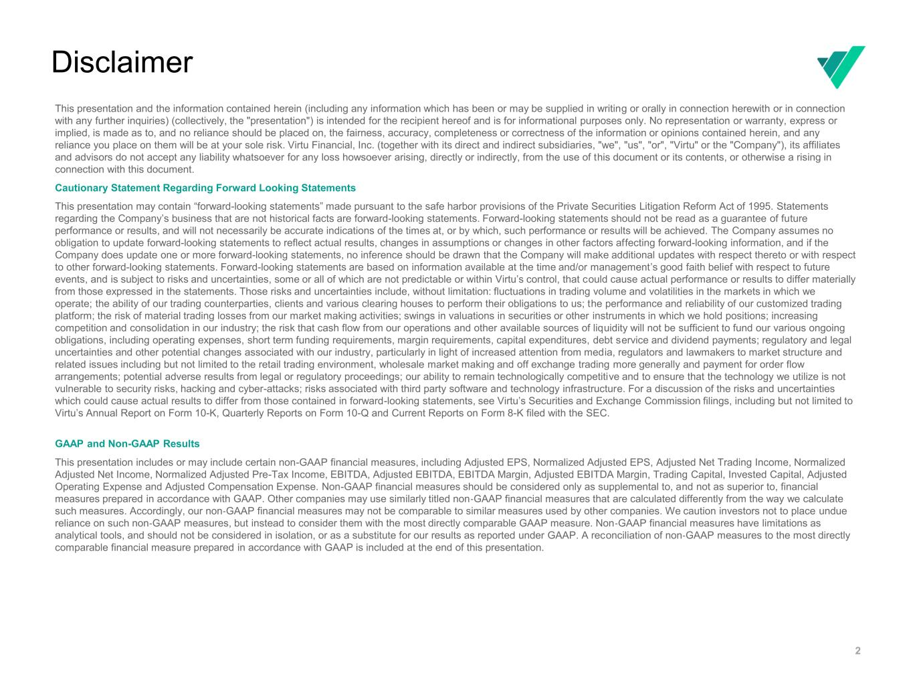
2 Disclaimer This presentation and the information contained herein (including any information which has been or may be supplied in writing or orally in connection herewith or in connection with any further inquiries) (collectively, the "presentation") is intended for the recipient hereof and is for informational purposes only. No representation or warranty, express or implied, is made as to, and no reliance should be placed on, the fairness, accuracy, completeness or correctness of the information or opinions contained herein, and any reliance you place on them will be at your sole risk. Virtu Financial, Inc. (together with its direct and indirect subsidiaries, "we", "us", "or", "Virtu" or the "Company"), its affiliates and advisors do not accept any liability whatsoever for any loss howsoever arising, directly or indirectly, from the use of this document or its contents, or otherwise a rising in connection with this document. Cautionary Statement Regarding Forward Looking Statements This presentation may contain “forward-looking statements” made pursuant to the safe harbor provisions of the Private Securities Litigation Reform Act of 1995. Statements regarding the Company’s business that are not historical facts are forward-looking statements. Forward-looking statements should not be read as a guarantee of future performance or results, and will not necessarily be accurate indications of the times at, or by which, such performance or results will be achieved. The Company assumes no obligation to update forward-looking statements to reflect actual results, changes in assumptions or changes in other factors affecting forward-looking information, and if the Company does update one or more forward-looking statements, no inference should be drawn that the Company will make additional updates with respect thereto or with respect to other forward-looking statements. Forward-looking statements are based on information available at the time and/or management’s good faith belief with respect to future events, and is subject to risks and uncertainties, some or all of which are not predictable or within Virtu’s control, that could cause actual performance or results to differ materially from those expressed in the statements. Those risks and uncertainties include, without limitation: fluctuations in trading volume and volatilities in the markets in which we operate; the ability of our trading counterparties, clients and various clearing houses to perform their obligations to us; the performance and reliability of our customized trading platform; the risk of material trading losses from our market making activities; swings in valuations in securities or other instruments in which we hold positions; increasing competition and consolidation in our industry; the risk that cash flow from our operations and other available sources of liquidity will not be sufficient to fund our various ongoing obligations, including operating expenses, short term funding requirements, margin requirements, capital expenditures, debt service and dividend payments; regulatory and legal uncertainties and other potential changes associated with our industry, particularly in light of increased attention from media, regulators and lawmakers to market structure and related issues including but not limited to the retail trading environment, wholesale market making and off exchange trading more generally and payment for order flow arrangements; potential adverse results from legal or regulatory proceedings; our ability to remain technologically competitive and to ensure that the technology we utilize is not vulnerable to security risks, hacking and cyber-attacks; risks associated with third party software and technology infrastructure. For a discussion of the risks and uncertainties which could cause actual results to differ from those contained in forward-looking statements, see Virtu’s Securities and Exchange Commission filings, including but not limited to Virtu’s Annual Report on Form 10-K, Quarterly Reports on Form 10-Q and Current Reports on Form 8-K filed with the SEC. GAAP and Non-GAAP Results This presentation includes or may include certain non-GAAP financial measures, including Adjusted EPS, Normalized Adjusted EPS, Adjusted Net Trading Income, Normalized Adjusted Net Income, Normalized Adjusted Pre-Tax Income, EBITDA, Adjusted EBITDA, EBITDA Margin, Adjusted EBITDA Margin, Trading Capital, Invested Capital, Adjusted Operating Expense and Adjusted Compensation Expense. Non-GAAP financial measures should be considered only as supplemental to, and not as superior to, financial measures prepared in accordance with GAAP. Other companies may use similarly titled non‐GAAP financial measures that are calculated differently from the way we calculate such measures. Accordingly, our non‐GAAP financial measures may not be comparable to similar measures used by other companies. We caution investors not to place undue reliance on such non‐GAAP measures, but instead to consider them with the most directly comparable GAAP measure. Non‐GAAP financial measures have limitations as analytical tools, and should not be considered in isolation, or as a substitute for our results as reported under GAAP. A reconciliation of non‐GAAP measures to the most directly comparable financial measure prepared in accordance with GAAP is included at the end of this presentation.


3 Speakers Joe Molluso Co-President and Co-Chief Operating Officer • Joined Virtu in 2013 as Chief Financial Officer • Played a central role in Virtu’s completed merger and integration of KCG Holdings and ITG as well as its initial public offering in 2015 • Previously served as Managing Director at J.P. Morgan in the Investment Banking Department, where he provided strategic advice to financial institutions with a focus on market structure related companies • Served on the Board of Directors of DTCC Cindy Lee Chief Financial Officer • Joined Virtu in 2011 and has served as the Global Controller and Deputy Chief Financial Officer • Previously served as an Audit Accountant at Deloitte & Touche • Certified Public Accountant Andrew Smith SVP, Global Business Development and Corporate Strategy • joined Virtu in 2009 and leads Global Business Development and Corporate Strategy, working to help grow and scale Virtu’s global market-making businesses • previously headed investor relations since the Company’s 2015 IPO • Member of Virtu’s Management Committee To confirm

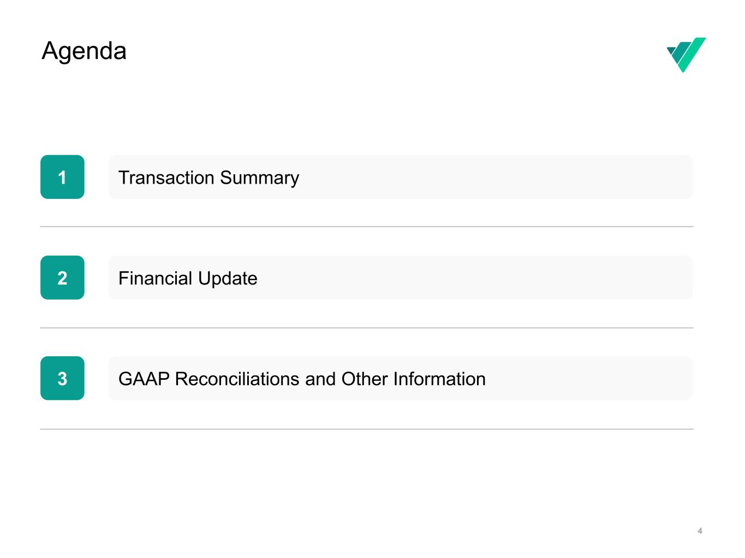
4 Agenda 1 2 3 Transaction Summary Financial Update GAAP Reconciliations and Other Information


Instructions are not visible during Show Mode To insert image • Drag the image from your source folder into the grey area • If the image overlaps/hides the text, right click on the image and select Arrange > Send to Back Slide Instructions Transaction Summary

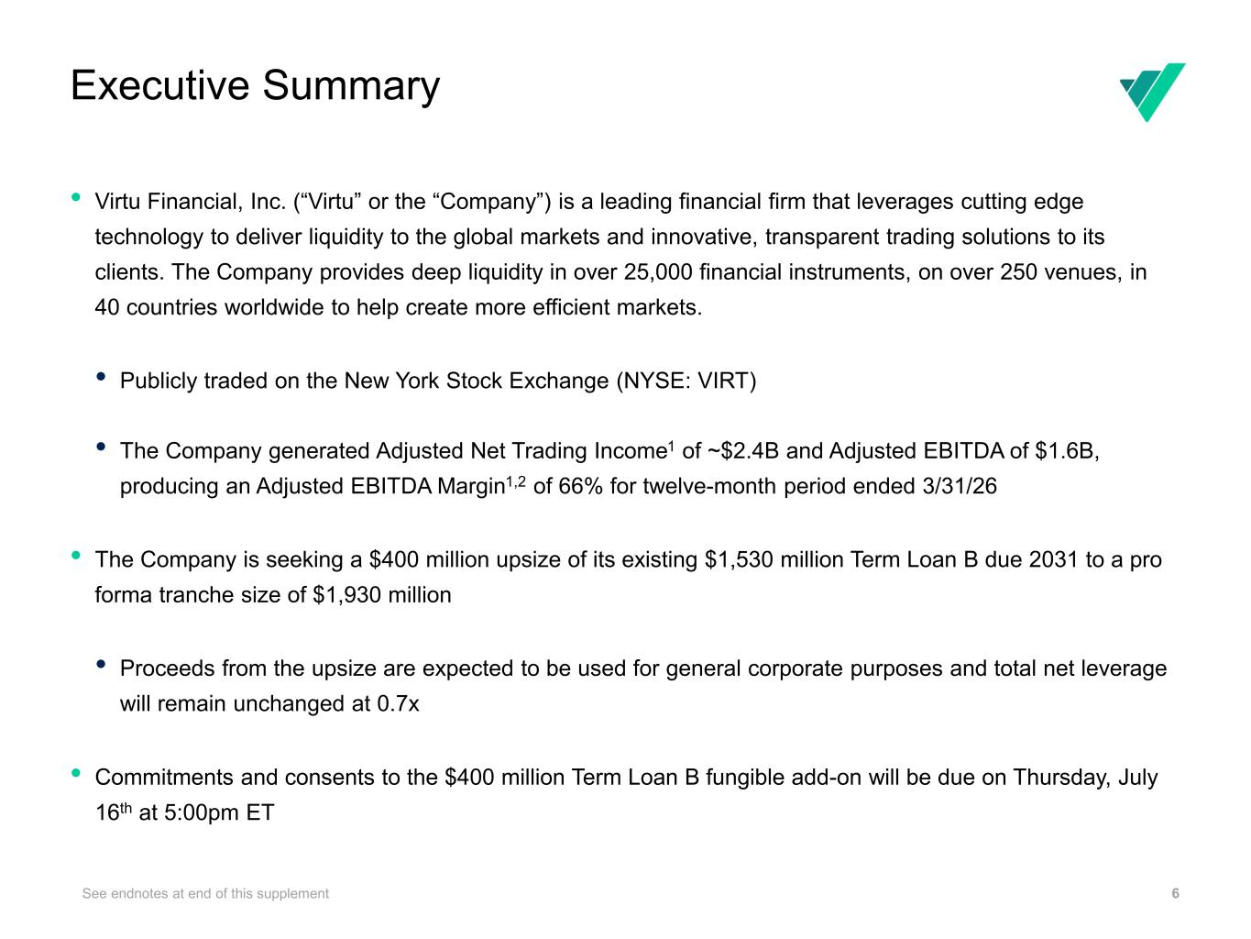
Executive Summary 6 Note: 1 Refer to appendix for a reconciliation of Adjusted EBITDA to net income, the most directly comparable GAAP financial measure; 2 Adjusted EBITDA margin is defined as Adjusted EBITDA divided by Adjusted Net Trading Income • Virtu Financial, Inc. (“Virtu” or the “Company”) is a leading financial firm that leverages cutting edge technology to deliver liquidity to the global markets and innovative, transparent trading solutions to its clients. The Company provides deep liquidity in over 25,000 financial instruments, on over 250 venues, in 40 countries worldwide to help create more efficient markets. • Publicly traded on the New York Stock Exchange (NYSE: VIRT) • The Company generated Adjusted Net Trading Income1 of ~$2.4B and Adjusted EBITDA of $1.6B, producing an Adjusted EBITDA Margin1,2 of 66% for twelve-month period ended 3/31/26 • The Company is seeking a $400 million upsize of its existing $1,530 million Term Loan B due 2031 to a pro forma tranche size of $1,930 million • Proceeds from the upsize are expected to be used for general corporate purposes and total net leverage will remain unchanged at 0.7x • Commitments and consents to the $400 million Term Loan B fungible add-on will be due on Thursday, July 16th at 5:00pm ET See endnotes at end of this supplement

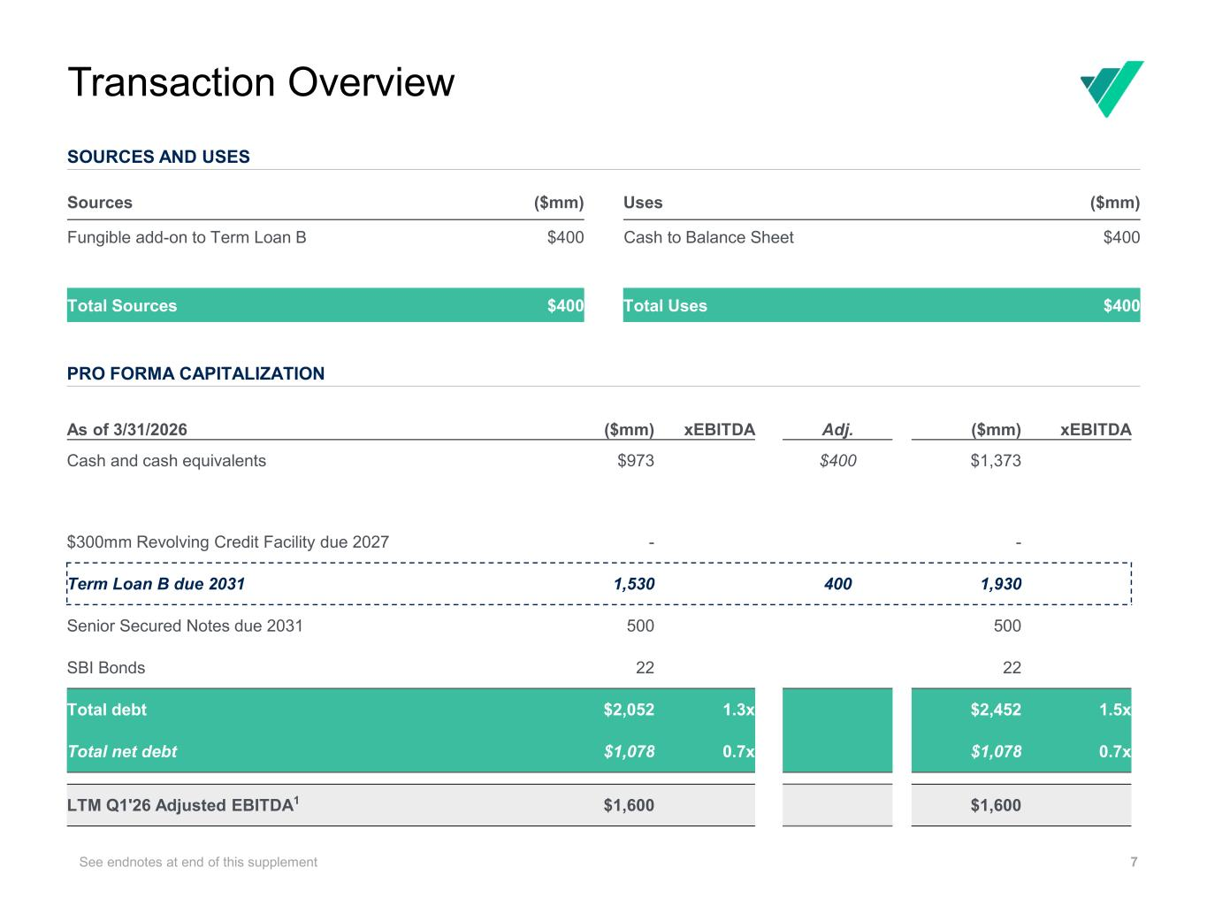
Transaction Overview 7 SOURCES AND USES Note: 1 Refer to appendix for a reconciliation of Adjusted EBITDA to net income, the most directly comparable GAAP financial measure Sources ($mm) Uses ($mm) Fungible add-on to Term Loan B $400 Cash to Balance Sheet $400 Total Sources $400 Total Uses $400 PRO FORMA CAPITALIZATION As of 3/31/2026 ($mm) xEBITDA Adj. ($mm) xEBITDA Cash and cash equivalents $973 $400 $1,373 $300mm Revolving Credit Facility due 2027 - - Term Loan B due 2031 1,530 400 1,930 Senior Secured Notes due 2031 500 500 SBI Bonds 22 22 Total debt $2,052 1.3x $2,452 1.5x Total net debt $1,078 0.7x $1,078 0.7x LTM Q1'26 Adjusted EBITDA1 $1,600 $1,600 See endnotes at end of this supplement

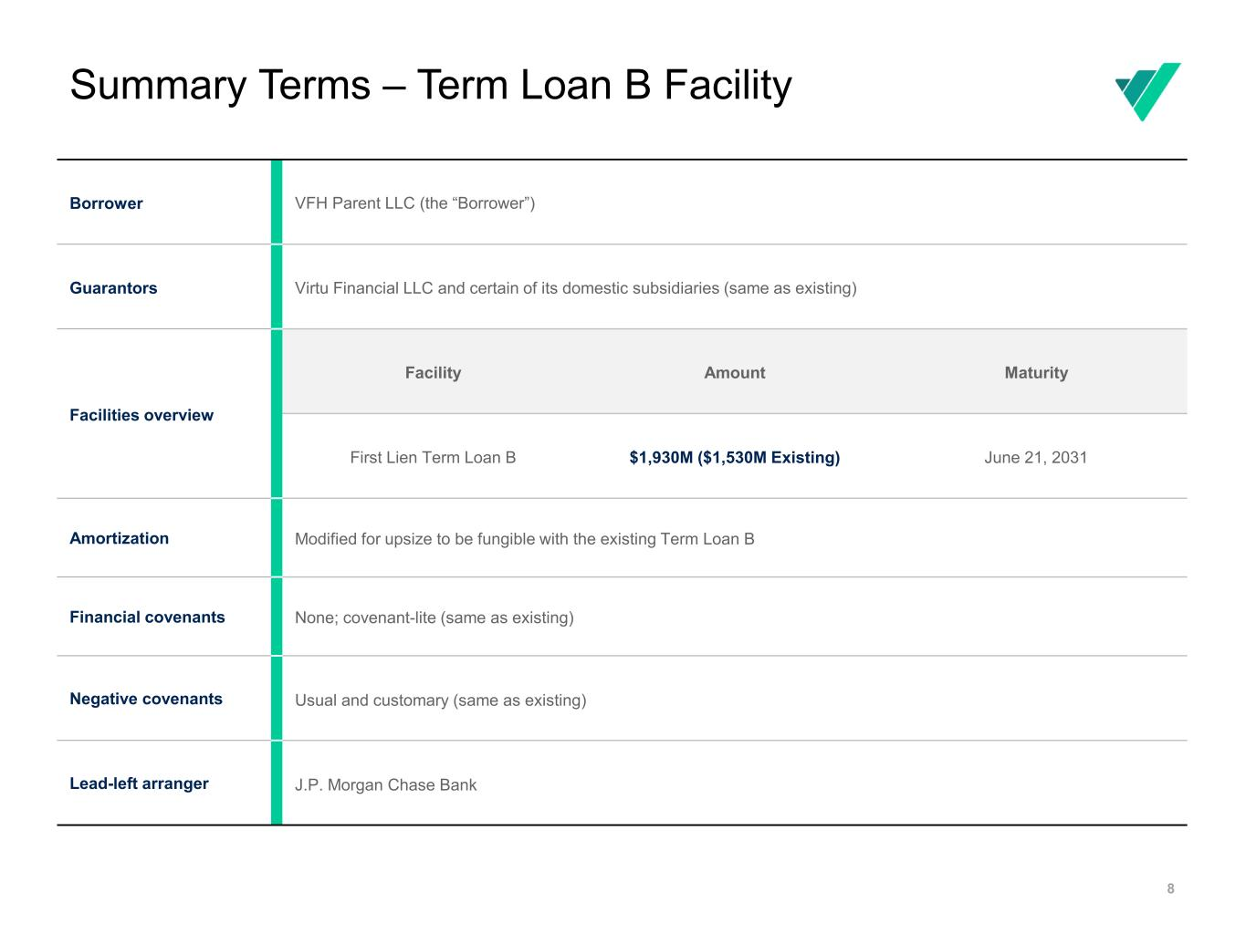
Summary Terms – Term Loan B Facility 8 Borrower VFH Parent LLC (the “Borrower”) Guarantors Virtu Financial LLC and certain of its domestic subsidiaries (same as existing) Facilities overview Facility Amount Maturity First Lien Term Loan B $1,930M ($1,530M Existing) June 21, 2031 Amortization Modified for upsize to be fungible with the existing Term Loan B Financial covenants None; covenant-lite (same as existing) Negative covenants Usual and customary (same as existing) Lead-left arranger J.P. Morgan Chase Bank

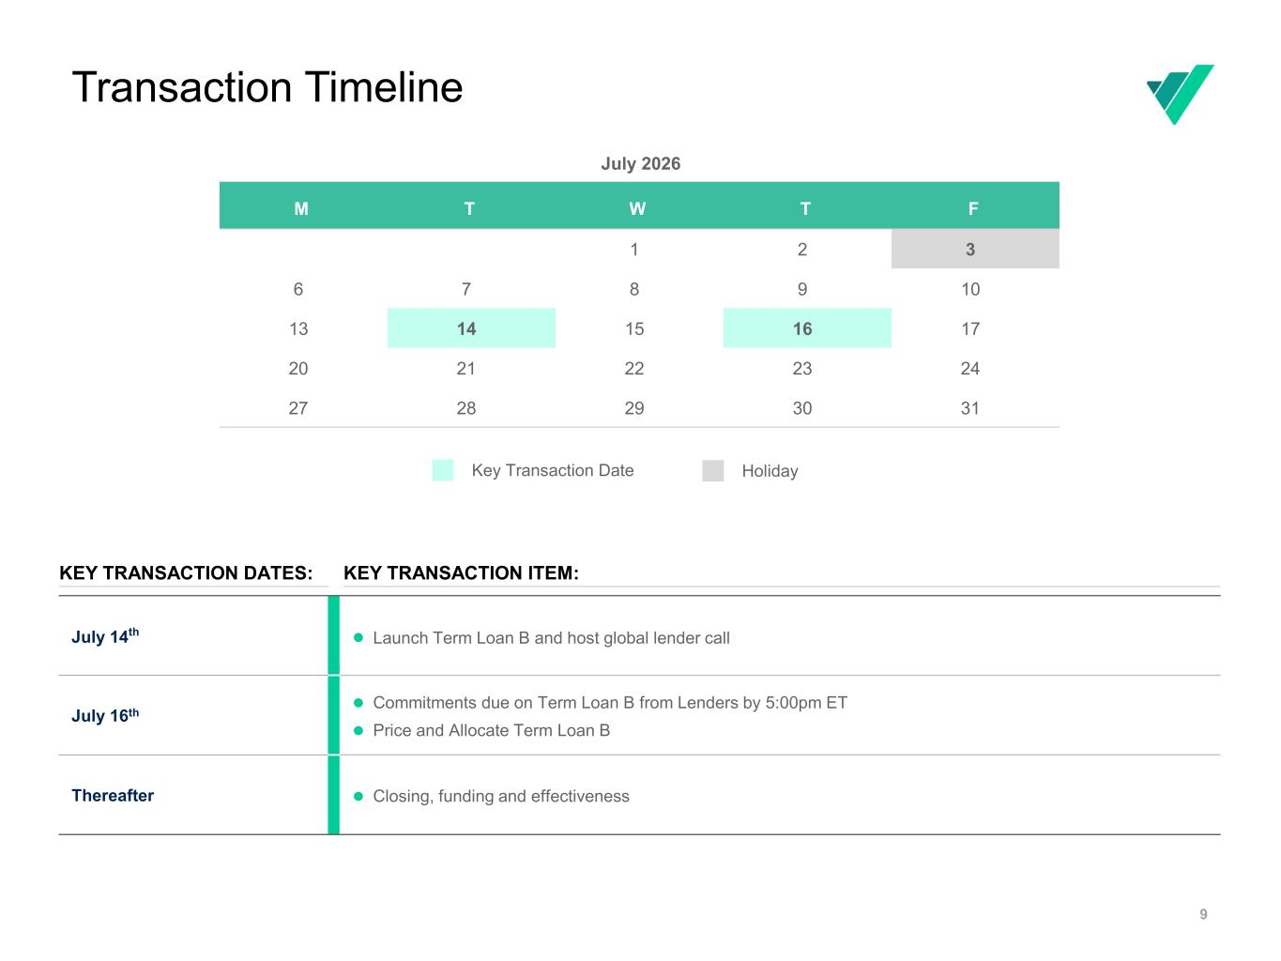
Transaction Timeline 9 July 14th ⚫ Launch Term Loan B and host global lender call July 16th ⚫ Commitments due on Term Loan B from Lenders by 5:00pm ET ⚫ Price and Allocate Term Loan B Thereafter ⚫ Closing, funding and effectiveness KEY TRANSACTION DATES: KEY TRANSACTION ITEM: Key Transaction Date July 2026 M T W T F 1 2 3 6 7 8 9 10 13 14 15 16 17 20 21 22 23 24 27 28 29 30 31 Holiday


Instructions are not visible during Show Mode To insert image • Drag the image from your source folder into the grey area • If the image overlaps/hides the text, right click on the image and select Arrange > Send to Back Slide Instructions Financial Update

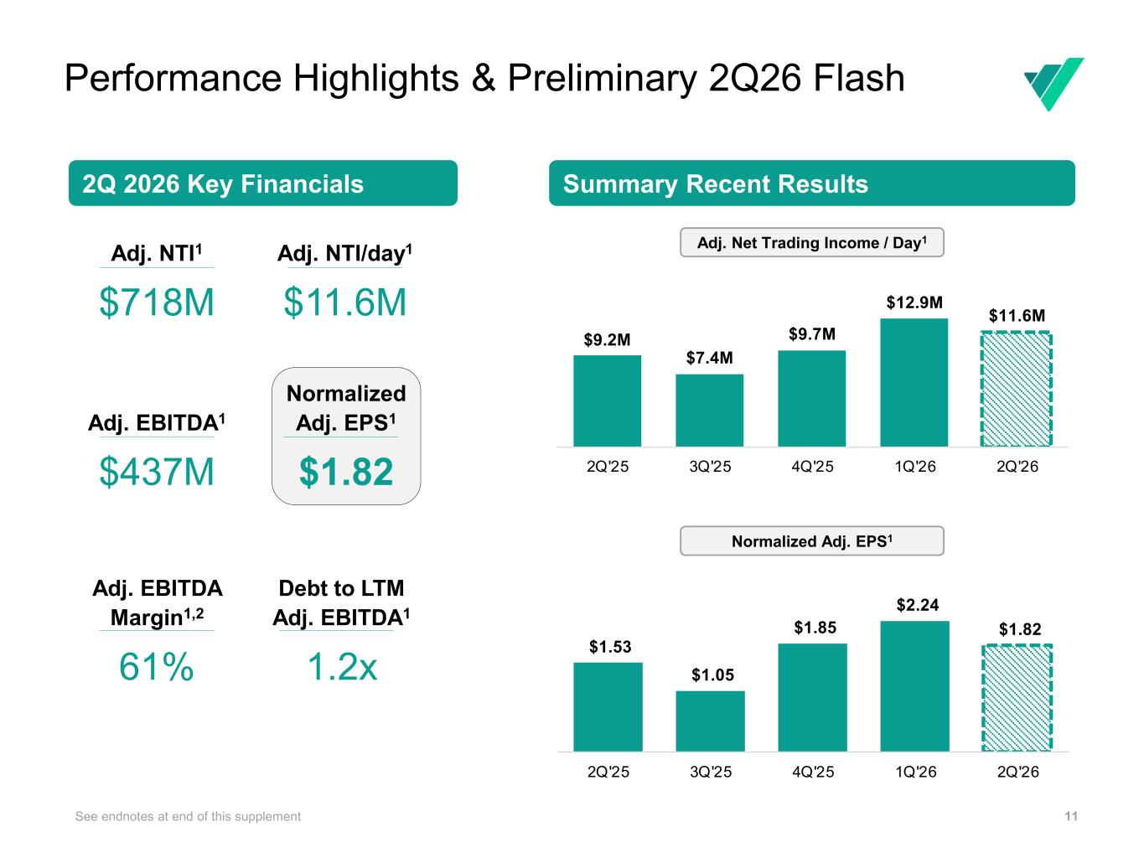
11 Normalized Adj. EPS1 $1.82 2Q 2026 Key Financials Summary Recent Results Adj. NTI1 $718M Adj. NTI/day1 $11.6M Adj. EBITDA1 $437M Adj. EBITDA Margin1,2 61% Debt to LTM Adj. EBITDA1 1.2x Performance Highlights & Preliminary 2Q26 Flash See endnotes at end of this supplement Updated Adj. Net Trading Income / Day1 Normalized Adj. EPS1 $9.2M $7.4M $9.7M $12.9M $11.6M 2Q'25 3Q'25 4Q'25 1Q'26 2Q'26 $1.53 $1.05 $1.85 $2.24 $1.82 2Q'25 3Q'25 4Q'25 1Q'26 2Q'26

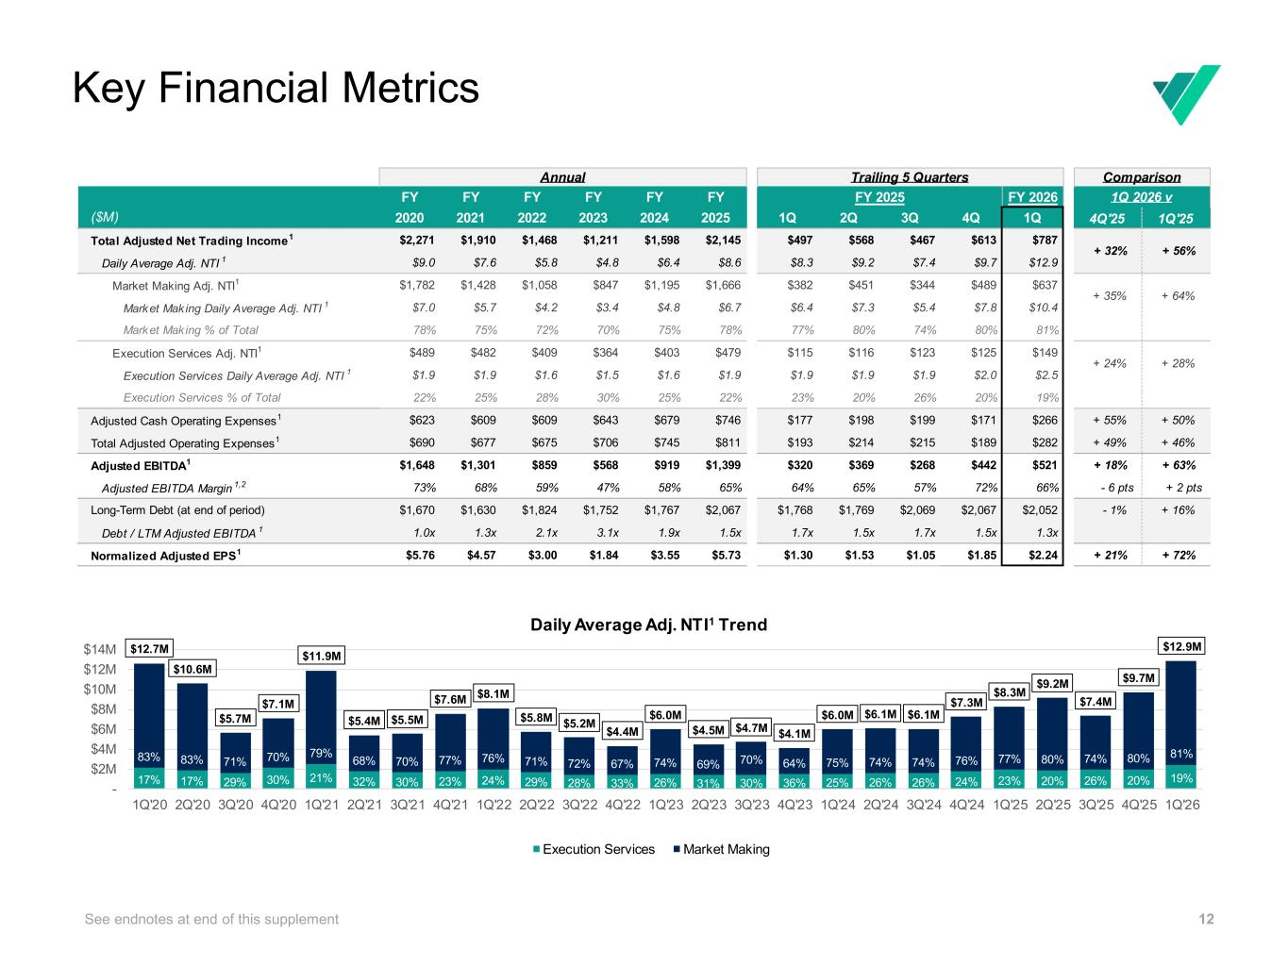
12 Key Financial Metrics See endnotes at end of this supplement FY FY FY FY FY FY 2020 2021 2022 2023 2024 2025 1Q 2Q 3Q 4Q 1Q 4Q'25 1Q'25 Total Adjusted Net Trading Income1 $2,271 $1,910 $1,468 $1,211 $1,598 $2,145 $497 $568 $467 $613 $787 Daily Average Adj. NTI 1 $9.0 $7.6 $5.8 $4.8 $6.4 $8.6 $8.3 $9.2 $7.4 $9.7 $12.9 Market Making Adj. NTI1 $1,782 $1,428 $1,058 $847 $1,195 $1,666 $382 $451 $344 $489 $637 Market Making Daily Average Adj. NTI 1 $7.0 $5.7 $4.2 $3.4 $4.8 $6.7 $6.4 $7.3 $5.4 $7.8 $10.4 Market Making % of Total 78% 75% 72% 70% 75% 78% 77% 80% 74% 80% 81% Execution Services Adj. NTI1 $489 $482 $409 $364 $403 $479 $115 $116 $123 $125 $149 Execution Services Daily Average Adj. NTI 1 $1.9 $1.9 $1.6 $1.5 $1.6 $1.9 $1.9 $1.9 $1.9 $2.0 $2.5 Execution Services % of Total 22% 25% 28% 30% 25% 22% 23% 20% 26% 20% 19% Adjusted Cash Operating Expenses1 $623 $609 $609 $643 $679 $746 $177 $198 $199 $171 $266 + 55% + 50% Total Adjusted Operating Expenses1 $690 $677 $675 $706 $745 $811 $193 $214 $215 $189 $282 + 49% + 46% Adjusted EBITDA1 $1,648 $1,301 $859 $568 $919 $1,399 $320 $369 $268 $442 $521 + 18% + 63% Adjusted EBITDA Margin 1,2 73% 68% 59% 47% 58% 65% 64% 65% 57% 72% 66% - 6 pts + 2 pts Long-Term Debt (at end of period) $1,670 $1,630 $1,824 $1,752 $1,767 $2,067 $1,768 $1,769 $2,069 $2,067 $2,052 - 1% + 16% Debt / LTM Adjusted EBITDA 1 1.0x 1.3x 2.1x 3.1x 1.9x 1.5x 1.7x 1.5x 1.7x 1.5x 1.3x Normalized Adjusted EPS1 $5.76 $4.57 $3.00 $1.84 $3.55 $5.73 $1.30 $1.53 $1.05 $1.85 $2.24 + 21% + 72% Trailing 5 Quarters FY 2026 Annual + 24% 1Q 2026 v Comparison FY 2025 + 28% + 32% + 56% + 35% + 64% ($M) 17% 17% 29% 30% 21% 32% 30% 23% 24% 29% 28% 33% 26% 31% 30% 36% 25% 26% 26% 24% 23% 20% 26% 20% 19% 83% 83% 71% 70% 79% 68% 70% 77% 76% 71% 72% 67% 74% 69% 70% 64% 75% 74% 74% 76% 77% 80% 74% 80% 81% $12.7M $10.6M $5.7M $7.1M $11.9M $5.4M $5.5M $7.6M $8.1M $5.8M $5.2M $4.4M $6.0M $4.5M $4.7M $4.1M $6.0M $6.1M $6.1M $7.3M $8.3M $9.2M $7.4M $9.7M $12.9M - $2M $4M $6M $8M $10M $12M $14M 1Q'20 2Q'20 3Q'20 4Q'20 1Q'21 2Q'21 3Q'21 4Q'21 1Q'22 2Q'22 3Q'22 4Q'22 1Q'23 2Q'23 3Q'23 4Q'23 1Q'24 2Q'24 3Q'24 4Q'24 1Q'25 2Q'25 3Q'25 4Q'25 1Q'26 Daily Average Adj. NTI1 Trend Execution Services Market Making

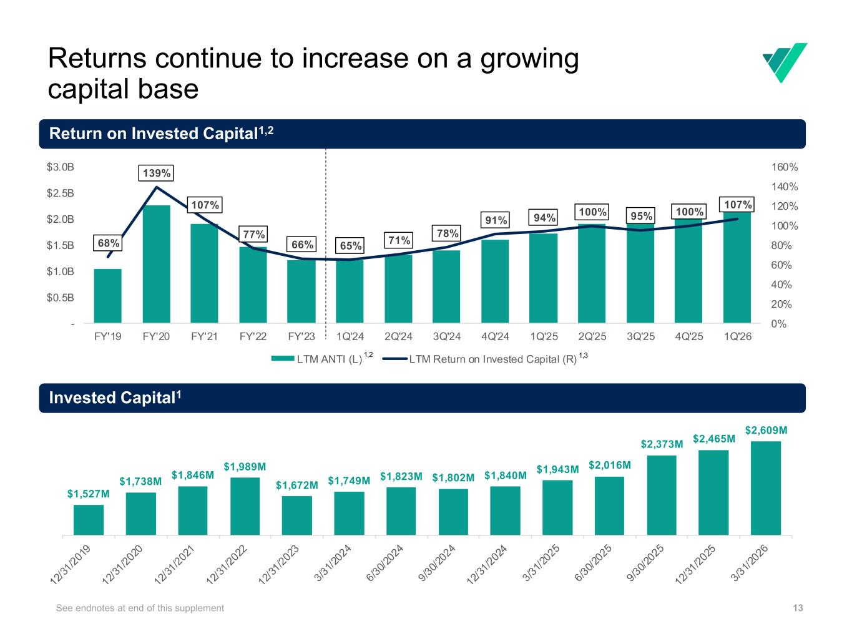
13 Return on Invested Capital1,2 See endnotes at end of this supplement Returns continue to increase on a growing capital base Invested Capital1 68% 139% 107% 77% 66% 65% 71% 78% 91% 94% 100% 95% 100% 107% 0% 20% 40% 60% 80% 100% 120% 140% 160% - $0.5B $1.0B $1.5B $2.0B $2.5B $3.0B FY'19 FY'20 FY'21 FY'22 FY'23 1Q'24 2Q'24 3Q'24 4Q'24 1Q'25 2Q'25 3Q'25 4Q'25 1Q'26 LTM ANTI (L) LTM Return on Invested Capital (R) 1,2 1,3 $1,527M $1,738M $1,846M $1,989M $1,672M $1,749M $1,823M $1,802M $1,840M $1,943M $2,016M $2,373M $2,465M $2,609M

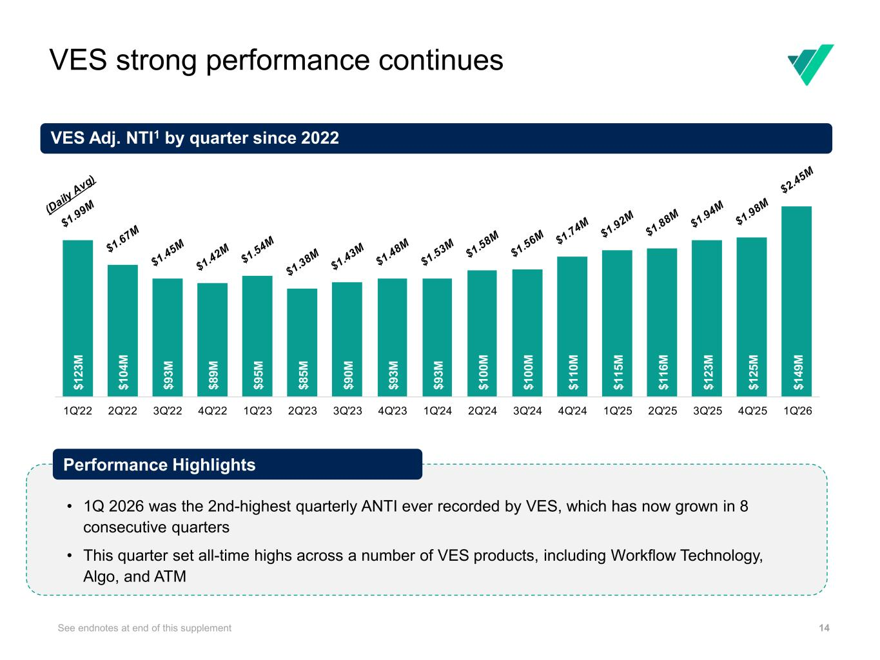
VES strong performance continues 14See endnotes at end of this supplement VES Adj. NTI1 by quarter since 2022 • 1Q 2026 was the 2nd-highest quarterly ANTI ever recorded by VES, which has now grown in 8 consecutive quarters • This quarter set all-time highs across a number of VES products, including Workflow Technology, Algo, and ATM Performance Highlights $ 1 2 3 M $ 1 0 4 M $ 9 3 M $ 8 9 M $ 9 5 M $ 8 5 M $ 9 0 M $ 9 3 M $ 9 3 M $ 1 0 0 M $ 1 0 0 M $ 1 1 0 M $ 1 1 5 M $ 1 1 6 M $ 1 2 3 M $ 1 2 5 M $ 1 4 9 M 1Q'22 2Q'22 3Q'22 4Q'22 1Q'23 2Q'23 3Q'23 4Q'23 1Q'24 2Q'24 3Q'24 4Q'24 1Q'25 2Q'25 3Q'25 4Q'25 1Q'26

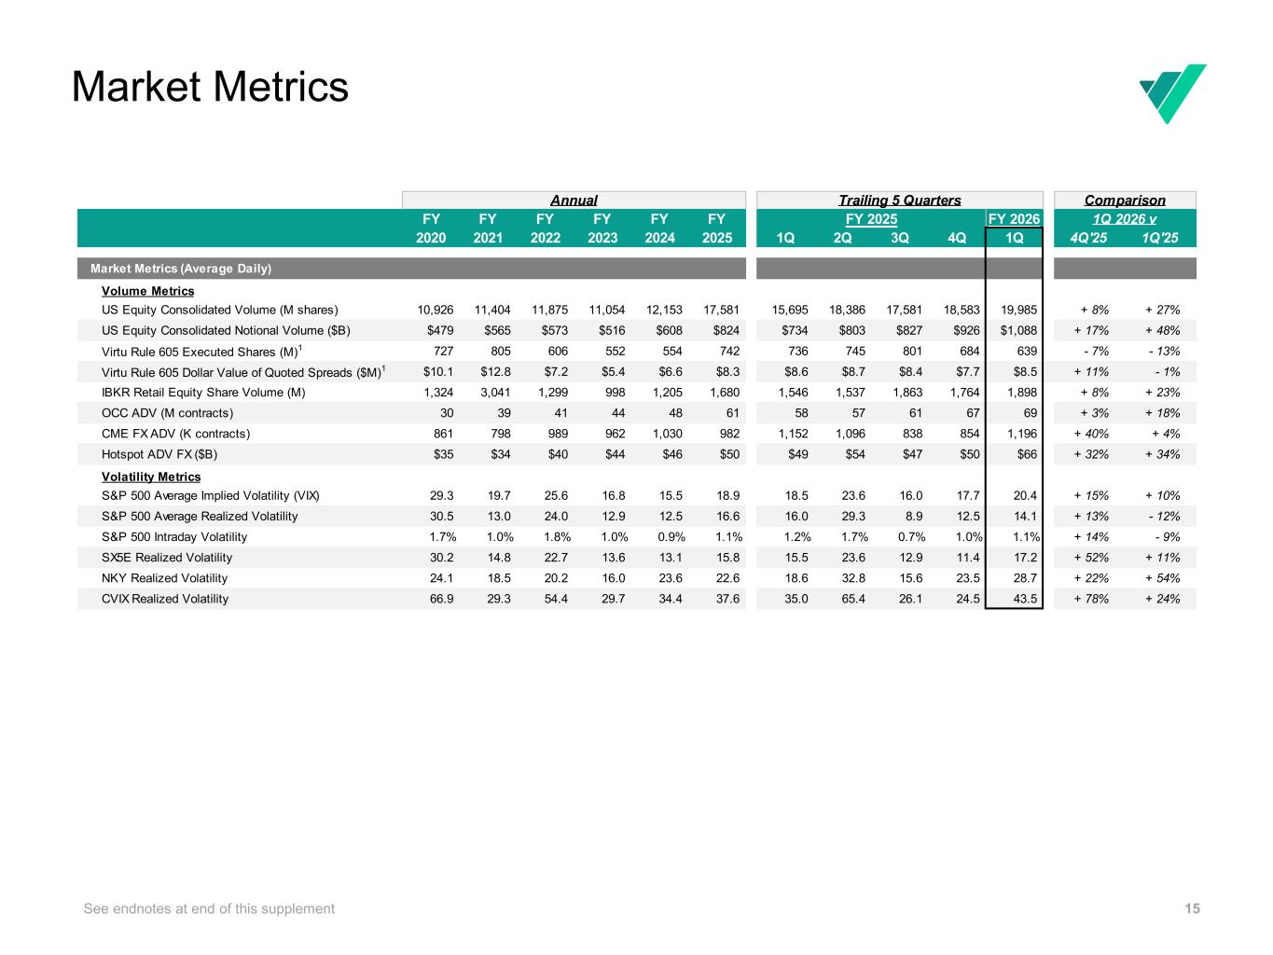
Market Metrics 15See endnotes at end of this supplement FY FY FY FY FY 2021 2022 2023 2024 2025 1Q 2Q 3Q 4Q 1Q 4Q'25 1Q'25 Market Metrics (Average Daily) Volume Metrics US Equity Consolidated Volume (M shares) 10,926 11,404 11,875 11,054 12,153 17,581 15,695 18,386 17,581 18,583 19,985 + 8% + 27% US Equity Consolidated Notional Volume ($B) $479 $565 $573 $516 $608 $824 $734 $803 $827 $926 $1,088 + 17% + 48% Virtu Rule 605 Executed Shares (M)1 727 805 606 552 554 742 736 745 801 684 639 - 7% - 13% Virtu Rule 605 Dollar Value of Quoted Spreads ($M)1 $10.1 $12.8 $7.2 $5.4 $6.6 $8.3 $8.6 $8.7 $8.4 $7.7 $8.5 + 11% - 1% IBKR Retail Equity Share Volume (M) 1,324 3,041 1,299 998 1,205 1,680 1,546 1,537 1,863 1,764 1,898 + 8% + 23% OCC ADV (M contracts) 30 39 41 44 48 61 58 57 61 67 69 + 3% + 18% CME FX ADV (K contracts) 861 798 989 962 1,030 982 1,152 1,096 838 854 1,196 + 40% + 4% Hotspot ADV FX ($B) $35 $34 $40 $44 $46 $50 $49 $54 $47 $50 $66 + 32% + 34% Volatility Metrics S&P 500 Average Implied Volatility (VIX) 29.3 19.7 25.6 16.8 15.5 18.9 18.5 23.6 16.0 17.7 20.4 + 15% + 10% S&P 500 Average Realized Volatility 30.5 13.0 24.0 12.9 12.5 16.6 16.0 29.3 8.9 12.5 14.1 + 13% - 12% S&P 500 Intraday Volatility 1.7% 1.0% 1.8% 1.0% 0.9% 1.1% 1.2% 1.7% 0.7% 1.0% 1.1% + 14% - 9% SX5E Realized Volatility 30.2 14.8 22.7 13.6 13.1 15.8 15.5 23.6 12.9 11.4 17.2 + 52% + 11% NKY Realized Volatility 24.1 18.5 20.2 16.0 23.6 22.6 18.6 32.8 15.6 23.5 28.7 + 22% + 54% CVIX Realized Volatility 66.9 29.3 54.4 29.7 34.4 37.6 35.0 65.4 26.1 24.5 43.5 + 78% + 24% FY 2025 1Q 2026 vFY 2026 Comparison FY 2020 Annual Trailing 5 Quarters

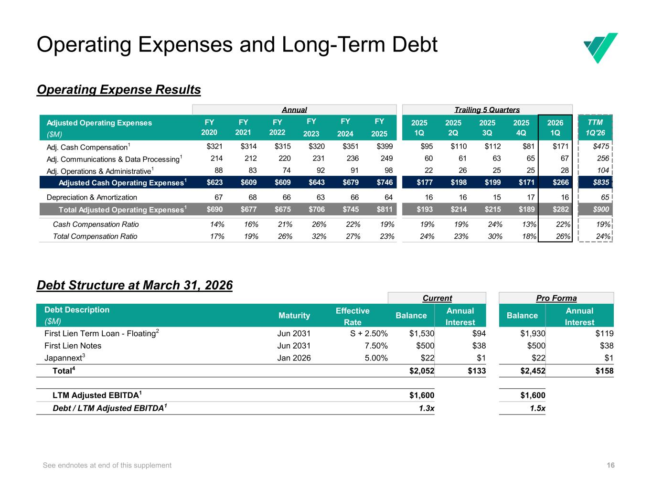
16 Operating Expenses and Long-Term Debt Operating Expense Results Debt Structure at March 31, 2026 See endnotes at end of this supplement Adjusted Operating Expenses FY FY FY 2025 2025 2025 2025 2026 TTM ($M) 2023 2024 2025 1Q 2Q 3Q 4Q 1Q 1Q'26 Adj. Cash Compensation1 $321 $314 $315 $320 $351 $399 $95 $110 $112 $81 $171 $475 Adj. Communications & Data Processing1 214 212 220 231 236 249 60 61 63 65 67 256 Adj. Operations & Administrative1 88 83 74 92 91 98 22 26 25 25 28 104 Adjusted Cash Operating Expenses1 $623 $609 $609 $643 $679 $746 $177 $198 $199 $171 $266 $835 Depreciation & Amortization 67 68 66 63 66 64 16 16 15 17 16 65 Total Adjusted Operating Expenses1 $690 $677 $675 $706 $745 $811 $193 $214 $215 $189 $282 $900 Cash Compensation Ratio 14% 16% 21% 26% 22% 19% 19% 19% 24% 13% 22% 19% Total Compensation Ratio 17% 19% 26% 32% 27% 23% 24% 23% 30% 18% 26% 24% Trailing 5 Quarters FY 2020 FY 2021 FY 2022 Annual Current Pro Forma Debt Description Maturity Effective Balance Annual Balance Annual ($M) Rate Interest Interest First Lien Term Loan - Floating2 Jun 2031 S + 2.50% $1,530 $94 $1,930 $119 First Lien Notes Jun 2031 7.50% $500 $38 $500 $38 Japannext3 Jan 2026 5.00% $22 $1 $22 $1 Total4 $2,052 $133 $2,452 $158 LTM Adjusted EBITDA1 $1,600 $1,600 Debt / LTM Adjusted EBITDA1 1.3x 1.5x


Instructions are not visible during Show Mode To insert image • Drag the image from your source folder into the grey area • If the image overlaps/hides the text, right click on the image and select Arrange > Send to Back Slide Instructions GAAP Reconciliations and Other Information

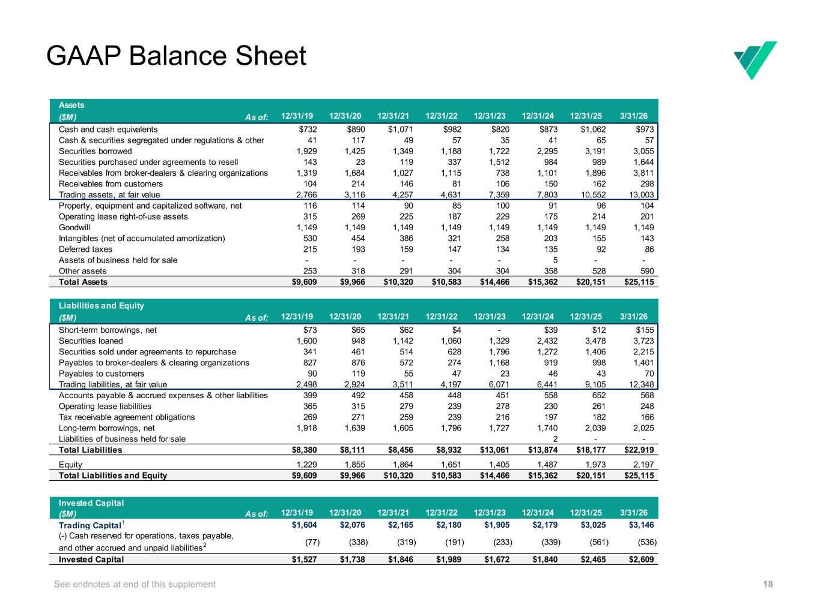
18 GAAP Balance Sheet See endnotes at end of this supplement Assets ($M) As of: 12/31/19 12/31/20 12/31/21 12/31/22 12/31/23 12/31/24 12/31/25 3/31/26 Cash and cash equivalents $732 $890 $1,071 $982 $820 $873 $1,062 $973 Cash & securities segregated under regulations & other 41 117 49 57 35 41 65 57 Securities borrowed 1,929 1,425 1,349 1,188 1,722 2,295 3,191 3,055 Securities purchased under agreements to resell 143 23 119 337 1,512 984 989 1,644 Receivables from broker-dealers & clearing organizations 1,319 1,684 1,027 1,115 738 1,101 1,896 3,811 Receivables from customers 104 214 146 81 106 150 162 298 Trading assets, at fair value 2,766 3,116 4,257 4,631 7,359 7,803 10,552 13,003 Property, equipment and capitalized software, net 116 114 90 85 100 91 96 104 Operating lease right-of-use assets 315 269 225 187 229 175 214 201 Goodwill 1,149 1,149 1,149 1,149 1,149 1,149 1,149 1,149 Intangibles (net of accumulated amortization) 530 454 386 321 258 203 155 143 Deferred taxes 215 193 159 147 134 135 92 86 Assets of business held for sale - - - - - 5 - - Other assets 253 318 291 304 304 358 528 590 Total Assets $9,609 $9,966 $10,320 $10,583 $14,466 $15,362 $20,151 $25,115 Liabilities and Equity ($M) As of: 12/31/19 12/31/20 12/31/21 12/31/22 12/31/23 12/31/24 12/31/25 3/31/26 Short-term borrowings, net $73 $65 $62 $4 - $39 $12 $155 Securities loaned 1,600 948 1,142 1,060 1,329 2,432 3,478 3,723 Securities sold under agreements to repurchase 341 461 514 628 1,796 1,272 1,406 2,215 Payables to broker-dealers & clearing organizations 827 876 572 274 1,168 919 998 1,401 Payables to customers 90 119 55 47 23 46 43 70 Trading liabilities, at fair value 2,498 2,924 3,511 4,197 6,071 6,441 9,105 12,348 Accounts payable & accrued expenses & other liabilities 399 492 458 448 451 558 652 568 Operating lease liabilities 365 315 279 239 278 230 261 248 Tax receivable agreement obligations 269 271 259 239 216 197 182 166 Long-term borrowings, net 1,918 1,639 1,605 1,796 1,727 1,740 2,039 2,025 Liabilities of business held for sale 2 - - Total Liabilities $8,380 $8,111 $8,456 $8,932 $13,061 $13,874 $18,177 $22,919 Equity 1,229 1,855 1,864 1,651 1,405 1,487 1,973 2,197 Total Liabilities and Equity $9,609 $9,966 $10,320 $10,583 $14,466 $15,362 $20,151 $25,115 Invested Capital ($M) As of: 12/31/19 12/31/20 12/31/21 12/31/22 12/31/23 12/31/24 12/31/25 3/31/26 Trading Capital1 $1,604 $2,076 $2,165 $2,180 $1,905 $2,179 $3,025 $3,146 (-) Cash reserved for operations, taxes payable, and other accrued and unpaid liabilities2 (77) (338) (319) (191) (233) (339) (561) (536) Invested Capital $1,527 $1,738 $1,846 $1,989 $1,672 $1,840 $2,465 $2,609

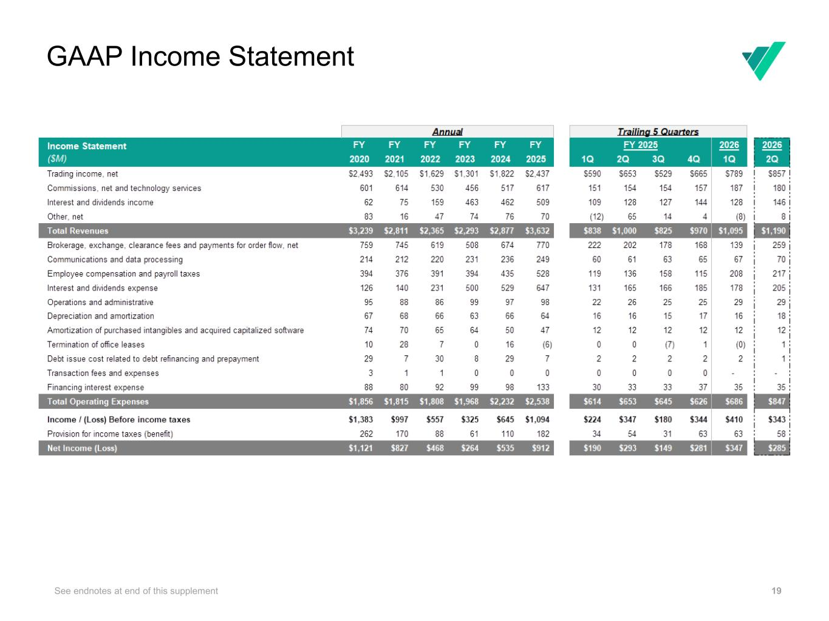
19 GAAP Income Statement See endnotes at end of this supplement

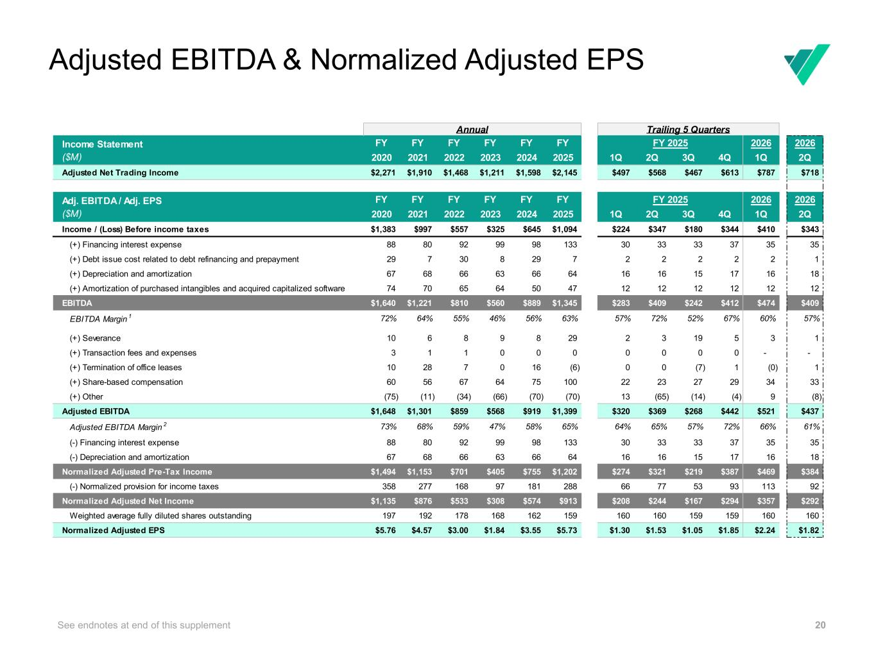
20 Adjusted Net Trading Income $975 $784 $669 $362 $456 $2,271 $724 Adjusted EBITDA & Normalized Adjusted EPS See endnotes at end of this supplement FY FY FY FY FY FY 2026 2020 2021 2022 2023 2024 2025 1Q 2Q 3Q 4Q 1Q 2Q Adjusted Net Trading Income $2,271 $1,910 $1,468 $1,211 $1,598 $2,145 $497 $568 $467 $613 $787 $718 FY FY FY FY FY FY 2026 2020 2021 2022 2023 2024 2025 1Q 2Q 3Q 4Q 1Q 2Q Income / (Loss) Before income taxes $1,383 $997 $557 $325 $645 $1,094 $224 $347 $180 $344 $410 $343 (+) Financing interest expense 88 80 92 99 98 133 30 33 33 37 35 35 (+) Debt issue cost related to debt refinancing and prepayment 29 7 30 8 29 7 2 2 2 2 2 1 (+) Depreciation and amortization 67 68 66 63 66 64 16 16 15 17 16 18 (+) Amortization of purchased intangibles and acquired capitalized software 74 70 65 64 50 47 12 12 12 12 12 12 EBITDA $1,640 $1,221 $810 $560 $889 $1,345 $283 $409 $242 $412 $474 $409 EBITDA Margin 1 72% 64% 55% 46% 56% 63% 57% 72% 52% 67% 60% 57% (+) Severance 10 6 8 9 8 29 2 3 19 5 3 1 (+) Transaction fees and expenses 3 1 1 0 0 0 0 0 0 0 - - (+) Termination of office leases 10 28 7 0 16 (6) 0 0 (7) 1 (0) 1 (+) Share-based compensation 60 56 67 64 75 100 22 23 27 29 34 33 (+) Other (75) (11) (34) (66) (70) (70) 13 (65) (14) (4) 9 (8) Adjusted EBITDA $1,648 $1,301 $859 $568 $919 $1,399 $320 $369 $268 $442 $521 $437 Adjusted EBITDA Margin 2 73% 68% 59% 47% 58% 65% 64% 65% 57% 72% 66% 61% (-) Financing interest expense 88 80 92 99 98 133 30 33 33 37 35 35 (-) Depreciation and amortization 67 68 66 63 66 64 16 16 15 17 16 18 Normalized Adjusted Pre-Tax Income $1,494 $1,153 $701 $405 $755 $1,202 $274 $321 $219 $387 $469 $384 (-) Normalized provision for income taxes 358 277 168 97 181 288 66 77 53 93 113 92 Normalized Adjusted Net Income $1,135 $876 $533 $308 $574 $913 $208 $244 $167 $294 $357 $292 Weighted average fully diluted shares outstanding 197 192 178 168 162 159 160 160 159 159 160 160 Normalized Adjusted EPS $5.76 $4.57 $3.00 $1.84 $3.55 $5.73 $1.30 $1.53 $1.05 $1.85 $2.24 $1.82 Adj. EBITDA / Adj. EPS ($M) Income Statement ($M) Annual Trailing 5 Quarters FY 2025 2026 2026FY 2025

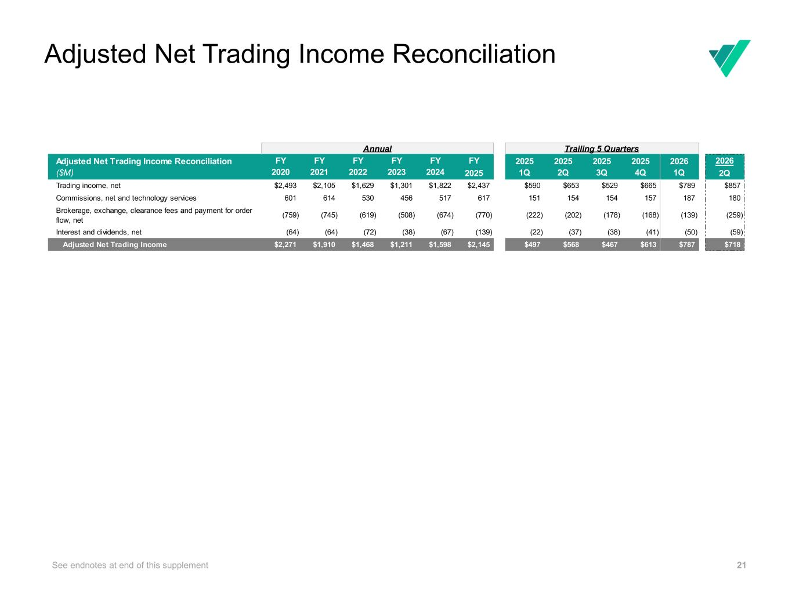
21 Adjusted Net Trading Income Reconciliation See endnotes at end of this supplement FY 2025 2025 2025 2025 2026 2026 2025 1Q 2Q 3Q 4Q 1Q 2Q Trading income, net $2,493 $2,105 $1,629 $1,301 $1,822 $2,437 $590 $653 $529 $665 $789 $857 Commissions, net and technology services 601 614 530 456 517 617 151 154 154 157 187 180 Brokerage, exchange, clearance fees and payment for order flow, net (759) (745) (619) (508) (674) (770) (222) (202) (178) (168) (139) (259) Interest and dividends, net (64) (64) (72) (38) (67) (139) (22) (37) (38) (41) (50) (59) Adjusted Net Trading Income $2,271 $1,910 $1,468 $1,211 $1,598 $2,145 $497 $568 $467 $613 $787 $718 Annual Trailing 5 Quarters Adjusted Net Trading Income Reconciliation ($M) FY 2020 FY 2021 FY 2022 FY 2023 FY 2024

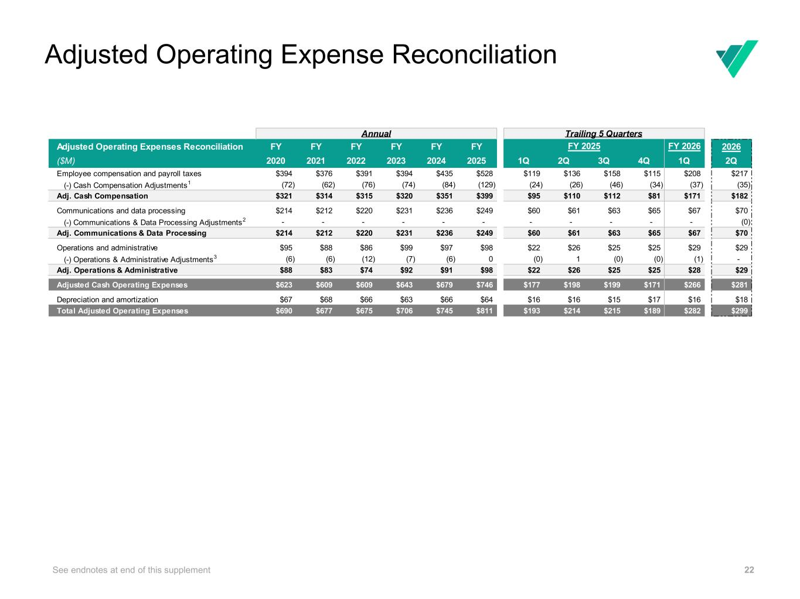
22 Adjusted Operating Expense Reconciliation See endnotes at end of this supplement Adjusted Operating Expenses Reconciliation FY FY FY FY FY FY 2026 ($M) 2020 2021 2022 2023 2024 2025 1Q 2Q 3Q 4Q 1Q 2Q Employee compensation and payroll taxes $394 $376 $391 $394 $435 $528 $119 $136 $158 $115 $208 $217 (-) Cash Compensation Adjustments1 (72) (62) (76) (74) (84) (129) (24) (26) (46) (34) (37) (35) Adj. Cash Compensation $321 $314 $315 $320 $351 $399 $95 $110 $112 $81 $171 $182 Communications and data processing $214 $212 $220 $231 $236 $249 $60 $61 $63 $65 $67 $70 (-) Communications & Data Processing Adjustments2 - - - - - - - - - - - (0) Adj. Communications & Data Processing $214 $212 $220 $231 $236 $249 $60 $61 $63 $65 $67 $70 Operations and administrative $95 $88 $86 $99 $97 $98 $22 $26 $25 $25 $29 $29 (-) Operations & Administrative Adjustments3 (6) (6) (12) (7) (6) 0 (0) 1 (0) (0) (1) - Adj. Operations & Administrative $88 $83 $74 $92 $91 $98 $22 $26 $25 $25 $28 $29 Adjusted Cash Operating Expenses $623 $609 $609 $643 $679 $746 $177 $198 $199 $171 $266 $281 Depreciation and amortization $67 $68 $66 $63 $66 $64 $16 $16 $15 $17 $16 $18 Total Adjusted Operating Expenses $690 $677 $675 $706 $745 $811 $193 $214 $215 $189 $282 $299 Annual Trailing 5 Quarters FY 2025 FY 2026

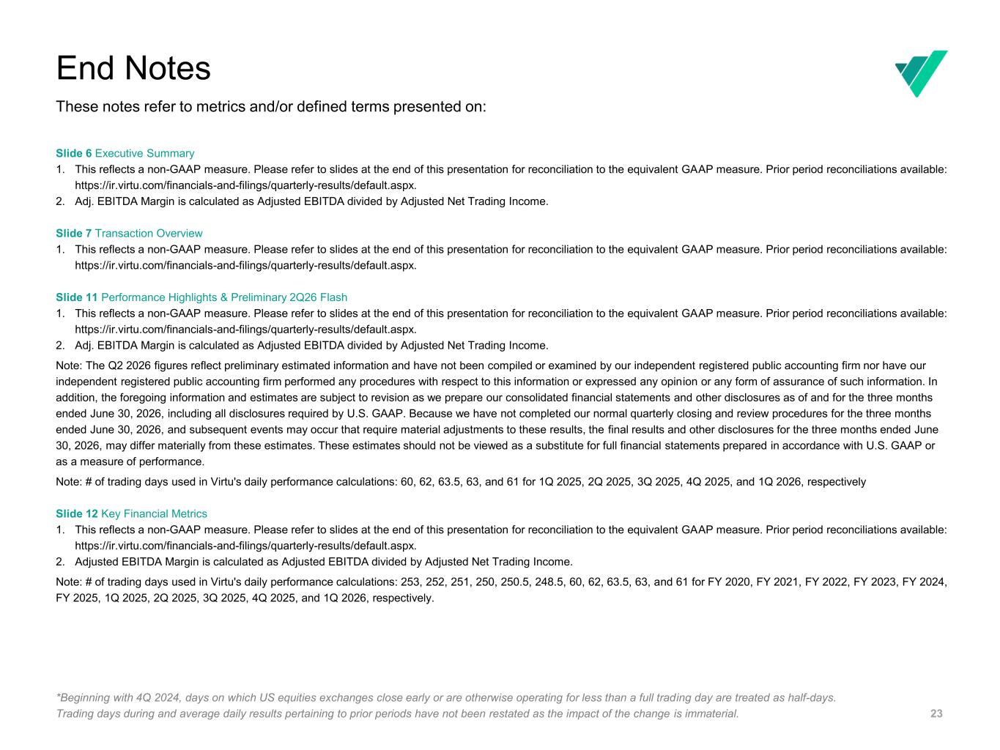
23 Slide 6 Executive Summary 1. This reflects a non-GAAP measure. Please refer to slides at the end of this presentation for reconciliation to the equivalent GAAP measure. Prior period reconciliations available: https://ir.virtu.com/financials-and-filings/quarterly-results/default.aspx. 2. Adj. EBITDA Margin is calculated as Adjusted EBITDA divided by Adjusted Net Trading Income. Slide 7 Transaction Overview 1. This reflects a non-GAAP measure. Please refer to slides at the end of this presentation for reconciliation to the equivalent GAAP measure. Prior period reconciliations available: https://ir.virtu.com/financials-and-filings/quarterly-results/default.aspx. Slide 11 Performance Highlights & Preliminary 2Q26 Flash 1. This reflects a non-GAAP measure. Please refer to slides at the end of this presentation for reconciliation to the equivalent GAAP measure. Prior period reconciliations available: https://ir.virtu.com/financials-and-filings/quarterly-results/default.aspx. 2. Adj. EBITDA Margin is calculated as Adjusted EBITDA divided by Adjusted Net Trading Income. Note: The Q2 2026 figures reflect preliminary estimated information and have not been compiled or examined by our independent registered public accounting firm nor have our independent registered public accounting firm performed any procedures with respect to this information or expressed any opinion or any form of assurance of such information. In addition, the foregoing information and estimates are subject to revision as we prepare our consolidated financial statements and other disclosures as of and for the three months ended June 30, 2026, including all disclosures required by U.S. GAAP. Because we have not completed our normal quarterly closing and review procedures for the three months ended June 30, 2026, and subsequent events may occur that require material adjustments to these results, the final results and other disclosures for the three months ended June 30, 2026, may differ materially from these estimates. These estimates should not be viewed as a substitute for full financial statements prepared in accordance with U.S. GAAP or as a measure of performance. Note: # of trading days used in Virtu's daily performance calculations: 60, 62, 63.5, 63, and 61 for 1Q 2025, 2Q 2025, 3Q 2025, 4Q 2025, and 1Q 2026, respectively Slide 12 Key Financial Metrics 1. This reflects a non-GAAP measure. Please refer to slides at the end of this presentation for reconciliation to the equivalent GAAP measure. Prior period reconciliations available: https://ir.virtu.com/financials-and-filings/quarterly-results/default.aspx. 2. Adjusted EBITDA Margin is calculated as Adjusted EBITDA divided by Adjusted Net Trading Income. Note: # of trading days used in Virtu's daily performance calculations: 253, 252, 251, 250, 250.5, 248.5, 60, 62, 63.5, 63, and 61 for FY 2020, FY 2021, FY 2022, FY 2023, FY 2024, FY 2025, 1Q 2025, 2Q 2025, 3Q 2025, 4Q 2025, and 1Q 2026, respectively. End Notes These notes refer to metrics and/or defined terms presented on: *Beginning with 4Q 2024, days on which US equities exchanges close early or are otherwise operating for less than a full trading day are treated as half-days. Trading days during and average daily results pertaining to prior periods have not been restated as the impact of the change is immaterial.

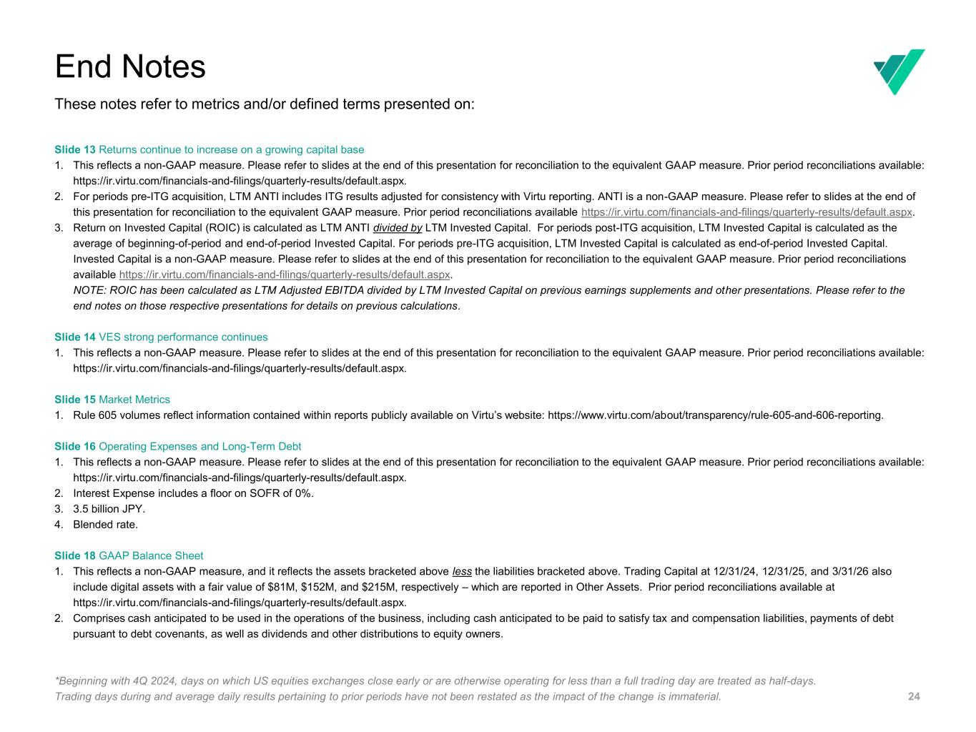
24 Slide 13 Returns continue to increase on a growing capital base 1. This reflects a non-GAAP measure. Please refer to slides at the end of this presentation for reconciliation to the equivalent GAAP measure. Prior period reconciliations available: https://ir.virtu.com/financials-and-filings/quarterly-results/default.aspx. 2. For periods pre-ITG acquisition, LTM ANTI includes ITG results adjusted for consistency with Virtu reporting. ANTI is a non-GAAP measure. Please refer to slides at the end of this presentation for reconciliation to the equivalent GAAP measure. Prior period reconciliations available https://ir.virtu.com/financials-and-filings/quarterly-results/default.aspx. 3. Return on Invested Capital (ROIC) is calculated as LTM ANTI divided by LTM Invested Capital. For periods post-ITG acquisition, LTM Invested Capital is calculated as the average of beginning-of-period and end-of-period Invested Capital. For periods pre-ITG acquisition, LTM Invested Capital is calculated as end-of-period Invested Capital. Invested Capital is a non-GAAP measure. Please refer to slides at the end of this presentation for reconciliation to the equivalent GAAP measure. Prior period reconciliations available https://ir.virtu.com/financials-and-filings/quarterly-results/default.aspx. NOTE: ROIC has been calculated as LTM Adjusted EBITDA divided by LTM Invested Capital on previous earnings supplements and other presentations. Please refer to the end notes on those respective presentations for details on previous calculations. Slide 14 VES strong performance continues 1. This reflects a non-GAAP measure. Please refer to slides at the end of this presentation for reconciliation to the equivalent GAAP measure. Prior period reconciliations available: https://ir.virtu.com/financials-and-filings/quarterly-results/default.aspx. Slide 15 Market Metrics 1. Rule 605 volumes reflect information contained within reports publicly available on Virtu’s website: https://www.virtu.com/about/transparency/rule-605-and-606-reporting. Slide 16 Operating Expenses and Long-Term Debt 1. This reflects a non-GAAP measure. Please refer to slides at the end of this presentation for reconciliation to the equivalent GAAP measure. Prior period reconciliations available: https://ir.virtu.com/financials-and-filings/quarterly-results/default.aspx. 2. Interest Expense includes a floor on SOFR of 0%. 3. 3.5 billion JPY. 4. Blended rate. Slide 18 GAAP Balance Sheet 1. This reflects a non-GAAP measure, and it reflects the assets bracketed above less the liabilities bracketed above. Trading Capital at 12/31/24, 12/31/25, and 3/31/26 also include digital assets with a fair value of $81M, $152M, and $215M, respectively – which are reported in Other Assets. Prior period reconciliations available at https://ir.virtu.com/financials-and-filings/quarterly-results/default.aspx. 2. Comprises cash anticipated to be used in the operations of the business, including cash anticipated to be paid to satisfy tax and compensation liabilities, payments of debt pursuant to debt covenants, as well as dividends and other distributions to equity owners. End Notes These notes refer to metrics and/or defined terms presented on: *Beginning with 4Q 2024, days on which US equities exchanges close early or are otherwise operating for less than a full trading day are treated as half-days. Trading days during and average daily results pertaining to prior periods have not been restated as the impact of the change is immaterial.

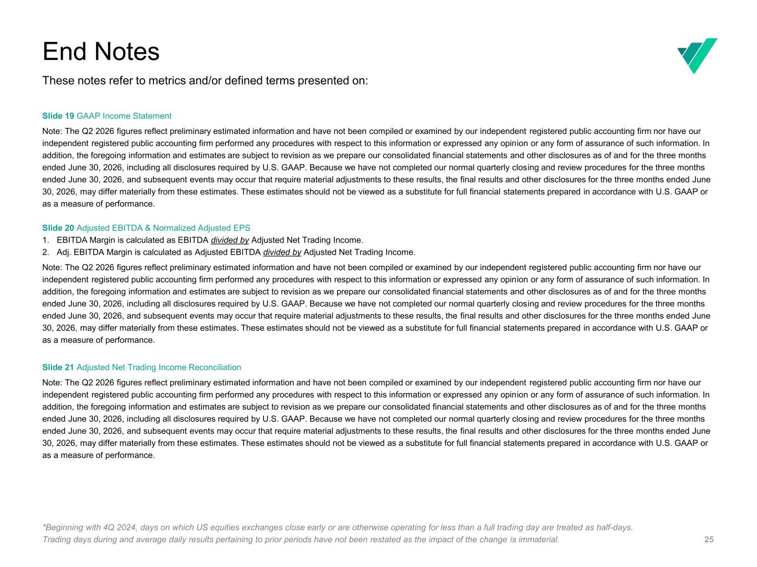
25 Slide 19 GAAP Income Statement Note: The Q2 2026 figures reflect preliminary estimated information and have not been compiled or examined by our independent registered public accounting firm nor have our independent registered public accounting firm performed any procedures with respect to this information or expressed any opinion or any form of assurance of such information. In addition, the foregoing information and estimates are subject to revision as we prepare our consolidated financial statements and other disclosures as of and for the three months ended June 30, 2026, including all disclosures required by U.S. GAAP. Because we have not completed our normal quarterly closing and review procedures for the three months ended June 30, 2026, and subsequent events may occur that require material adjustments to these results, the final results and other disclosures for the three months ended June 30, 2026, may differ materially from these estimates. These estimates should not be viewed as a substitute for full financial statements prepared in accordance with U.S. GAAP or as a measure of performance. Slide 20 Adjusted EBITDA & Normalized Adjusted EPS 1. EBITDA Margin is calculated as EBITDA divided by Adjusted Net Trading Income. 2. Adj. EBITDA Margin is calculated as Adjusted EBITDA divided by Adjusted Net Trading Income. Note: The Q2 2026 figures reflect preliminary estimated information and have not been compiled or examined by our independent registered public accounting firm nor have our independent registered public accounting firm performed any procedures with respect to this information or expressed any opinion or any form of assurance of such information. In addition, the foregoing information and estimates are subject to revision as we prepare our consolidated financial statements and other disclosures as of and for the three months ended June 30, 2026, including all disclosures required by U.S. GAAP. Because we have not completed our normal quarterly closing and review procedures for the three months ended June 30, 2026, and subsequent events may occur that require material adjustments to these results, the final results and other disclosures for the three months ended June 30, 2026, may differ materially from these estimates. These estimates should not be viewed as a substitute for full financial statements prepared in accordance with U.S. GAAP or as a measure of performance. Slide 21 Adjusted Net Trading Income Reconciliation Note: The Q2 2026 figures reflect preliminary estimated information and have not been compiled or examined by our independent registered public accounting firm nor have our independent registered public accounting firm performed any procedures with respect to this information or expressed any opinion or any form of assurance of such information. In addition, the foregoing information and estimates are subject to revision as we prepare our consolidated financial statements and other disclosures as of and for the three months ended June 30, 2026, including all disclosures required by U.S. GAAP. Because we have not completed our normal quarterly closing and review procedures for the three months ended June 30, 2026, and subsequent events may occur that require material adjustments to these results, the final results and other disclosures for the three months ended June 30, 2026, may differ materially from these estimates. These estimates should not be viewed as a substitute for full financial statements prepared in accordance with U.S. GAAP or as a measure of performance. End Notes These notes refer to metrics and/or defined terms presented on: *Beginning with 4Q 2024, days on which US equities exchanges close early or are otherwise operating for less than a full trading day are treated as half-days. Trading days during and average daily results pertaining to prior periods have not been restated as the impact of the change is immaterial.

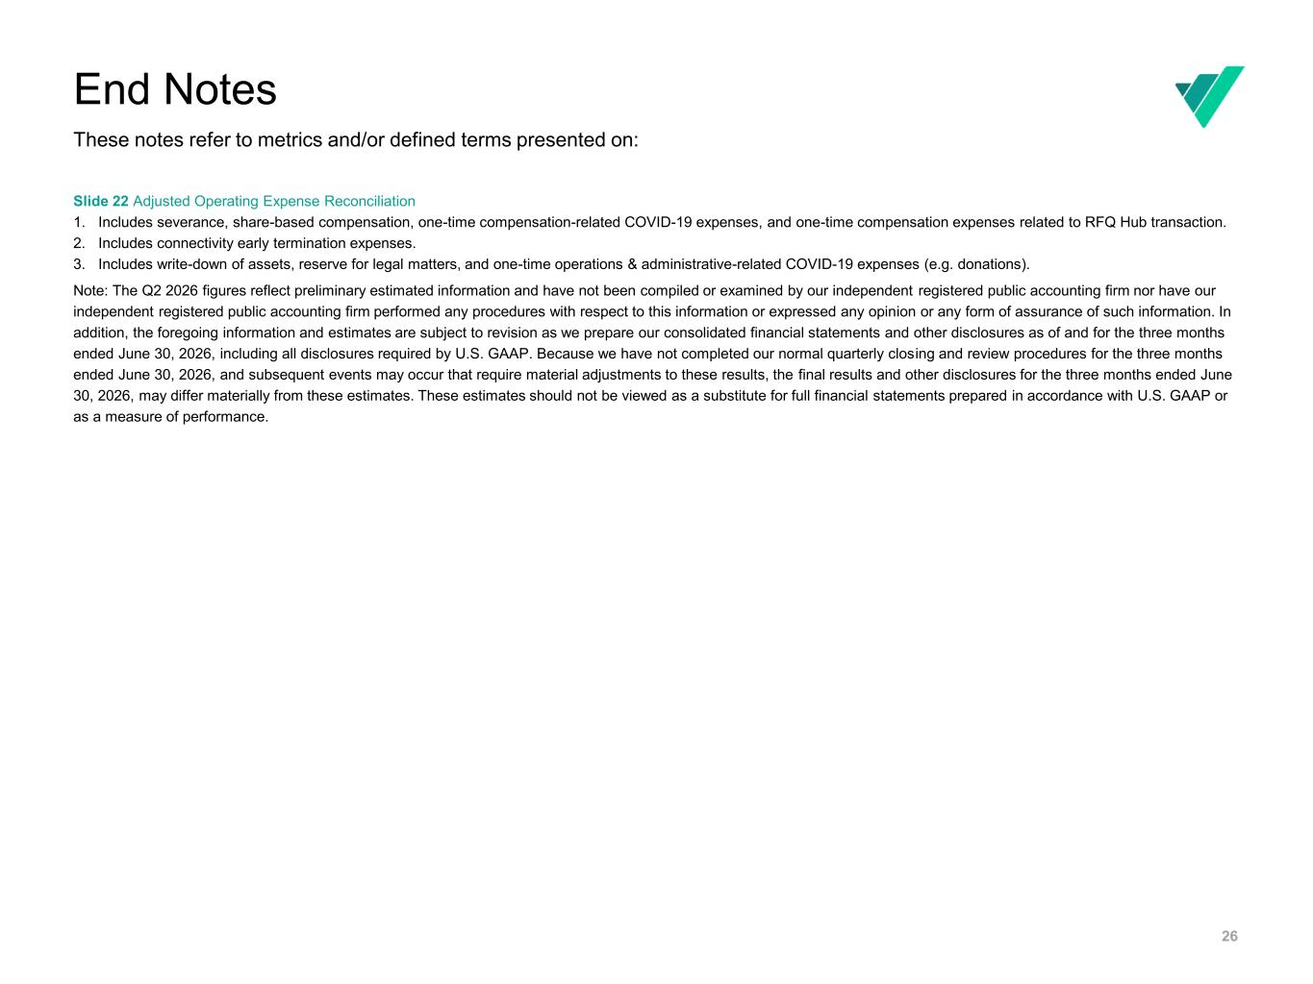
26 Slide 22 Adjusted Operating Expense Reconciliation 1. Includes severance, share-based compensation, one-time compensation-related COVID-19 expenses, and one-time compensation expenses related to RFQ Hub transaction. 2. Includes connectivity early termination expenses. 3. Includes write-down of assets, reserve for legal matters, and one-time operations & administrative-related COVID-19 expenses (e.g. donations). Note: The Q2 2026 figures reflect preliminary estimated information and have not been compiled or examined by our independent registered public accounting firm nor have our independent registered public accounting firm performed any procedures with respect to this information or expressed any opinion or any form of assurance of such information. In addition, the foregoing information and estimates are subject to revision as we prepare our consolidated financial statements and other disclosures as of and for the three months ended June 30, 2026, including all disclosures required by U.S. GAAP. Because we have not completed our normal quarterly closing and review procedures for the three months ended June 30, 2026, and subsequent events may occur that require material adjustments to these results, the final results and other disclosures for the three months ended June 30, 2026, may differ materially from these estimates. These estimates should not be viewed as a substitute for full financial statements prepared in accordance with U.S. GAAP or as a measure of performance. End Notes These notes refer to metrics and/or defined terms presented on:

